**Final Stage Currency Localisation**

**MA_GBR_0650AAx0400**

There are no 1c NZ coins so requires complete content change as replacing coins would change outcome of algorithm

e.g. replacing coins with 20c and 10c respectively would change answer from 23 to 70

Similar issue for the test

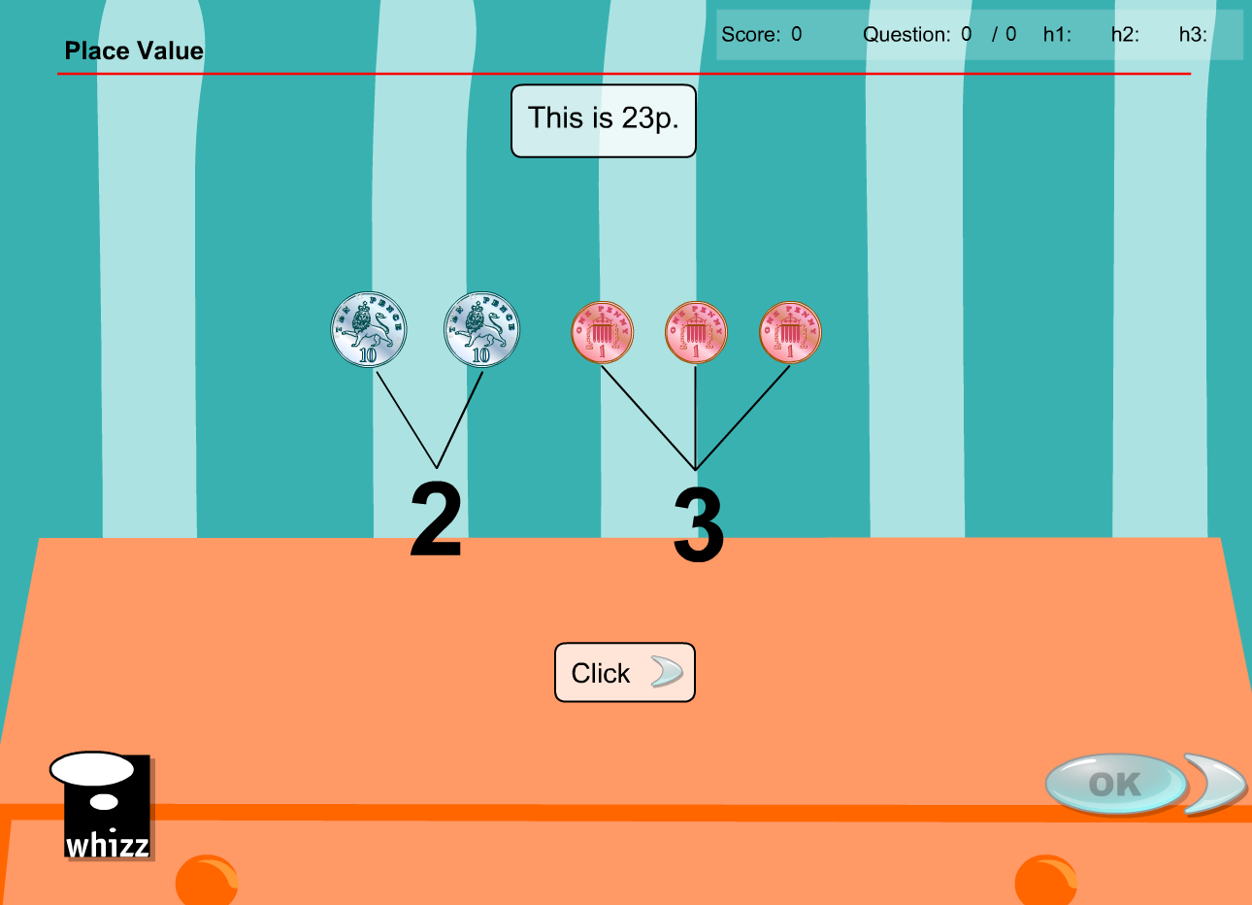

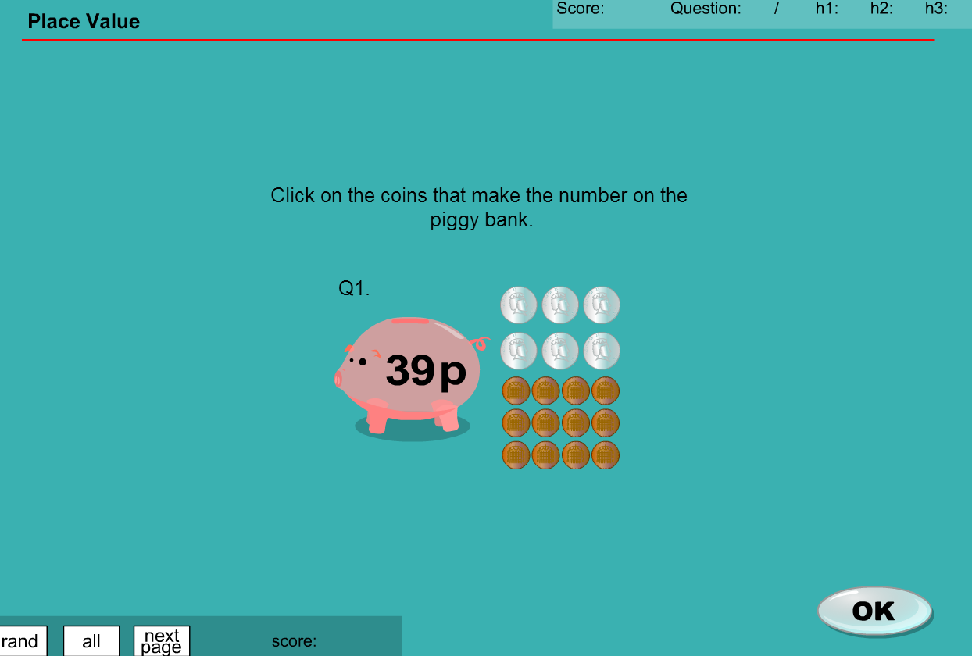

**MA_GBR_0650AAx0400 – fixes**

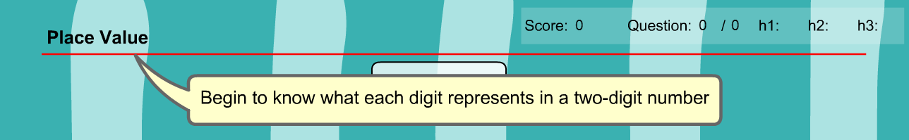

Achievement objective does not specifically refer to money, so could the content be replaced by tokens of equivalent values.

Question 1

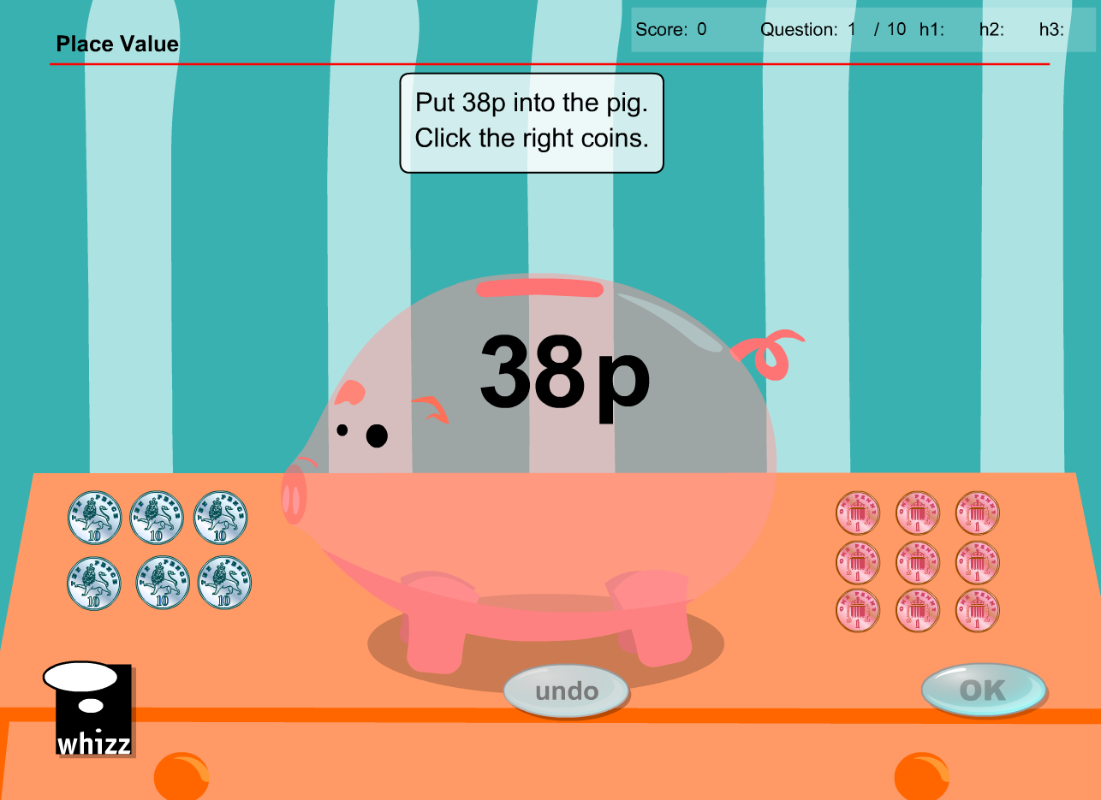

* Use tokens of the same denomination
* Question reworded “Put tokens to the value of 28 into the pig. Click on the right tokens.”

Question 2

* As per Question 1

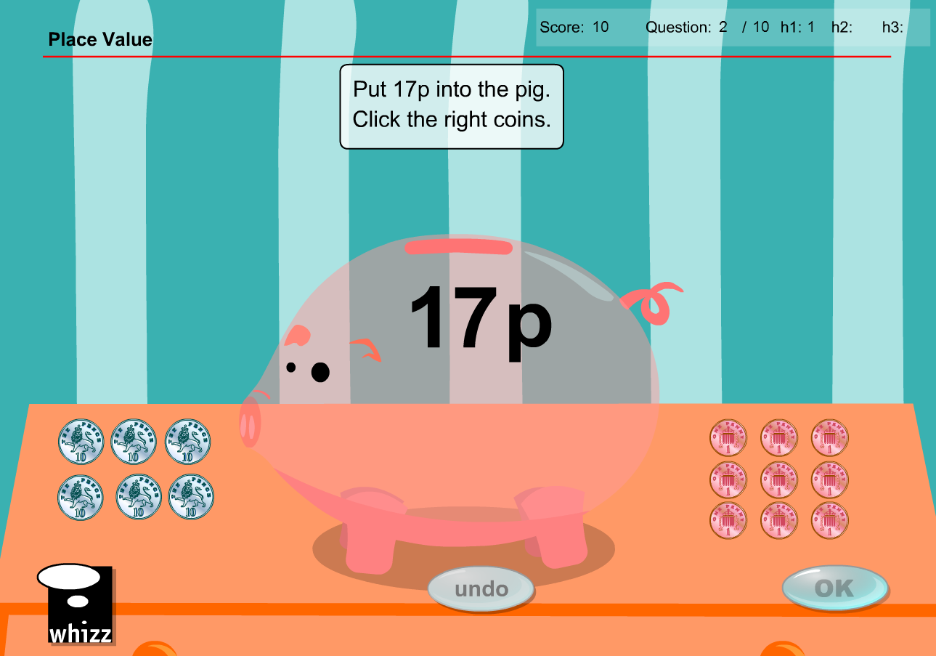

Question 3

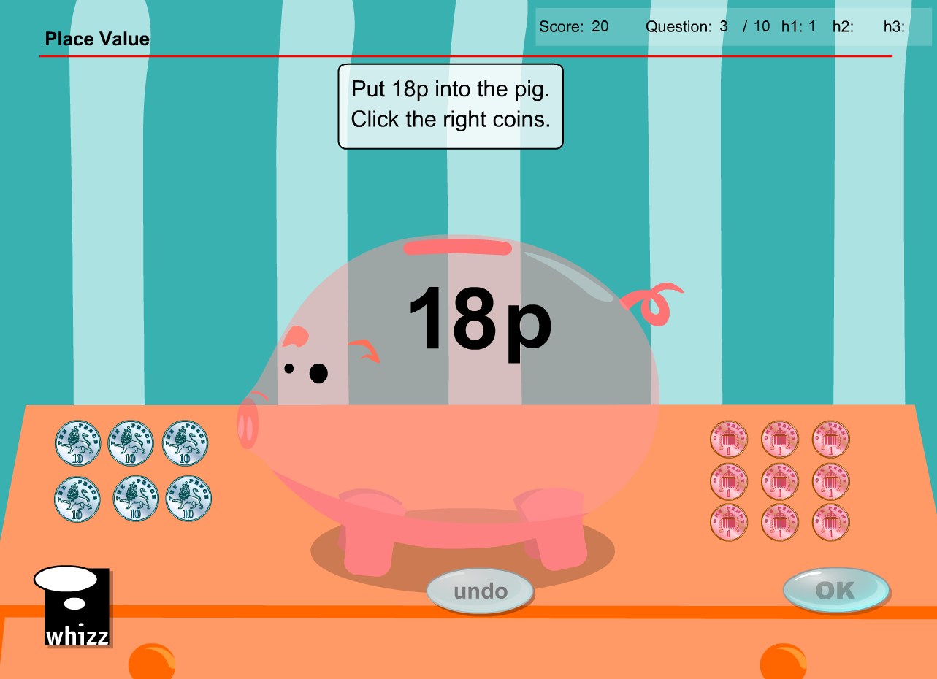

* As per Question 1

Question 4

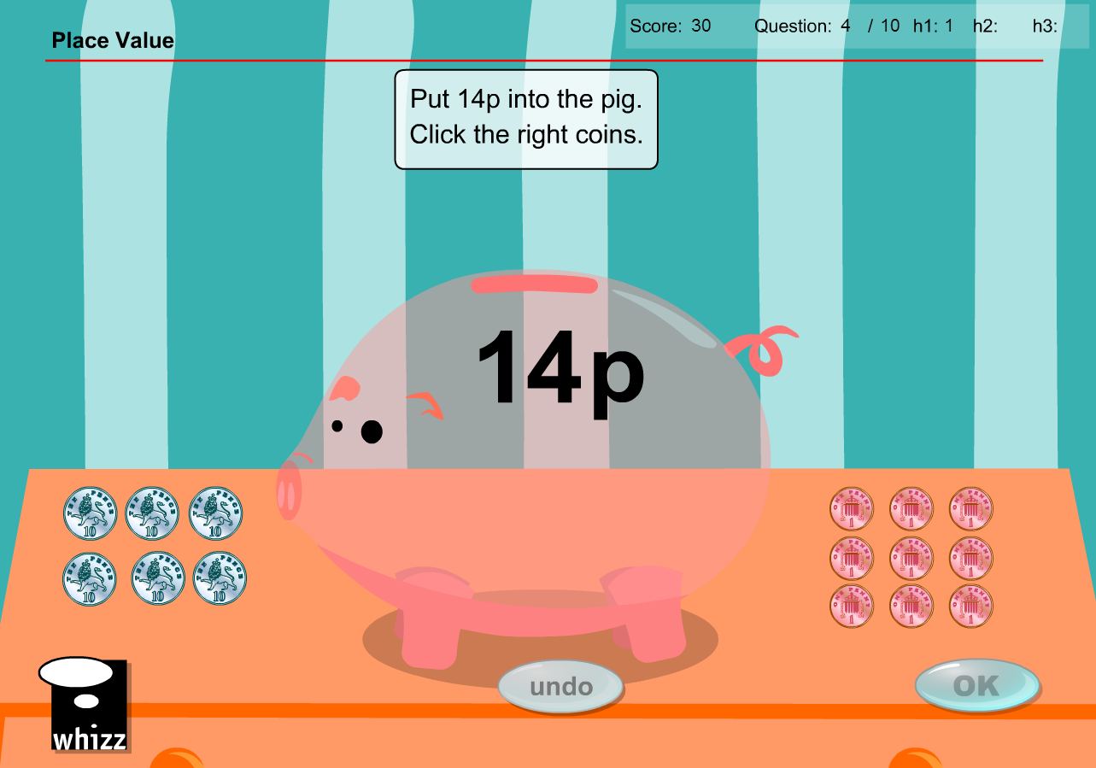

* As per Question 1

Question 5

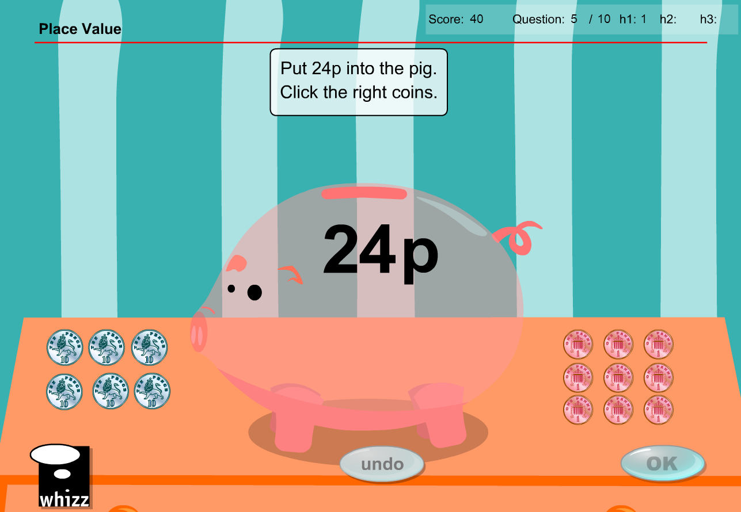

* As per Question 1

Question 6

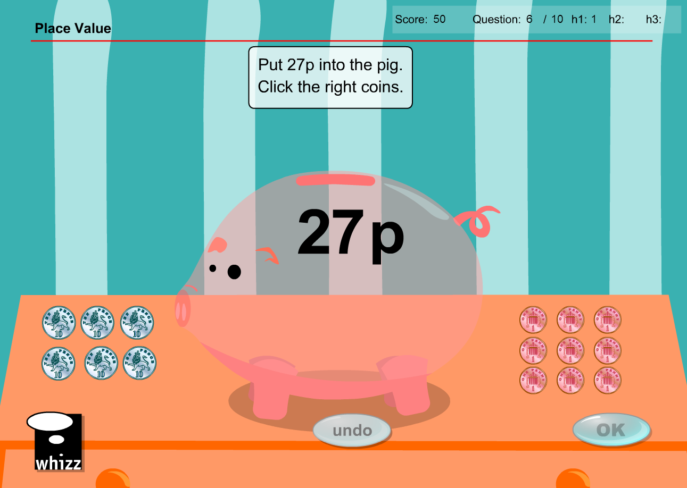

* As per Question 1

Question 7

* As per Question 1

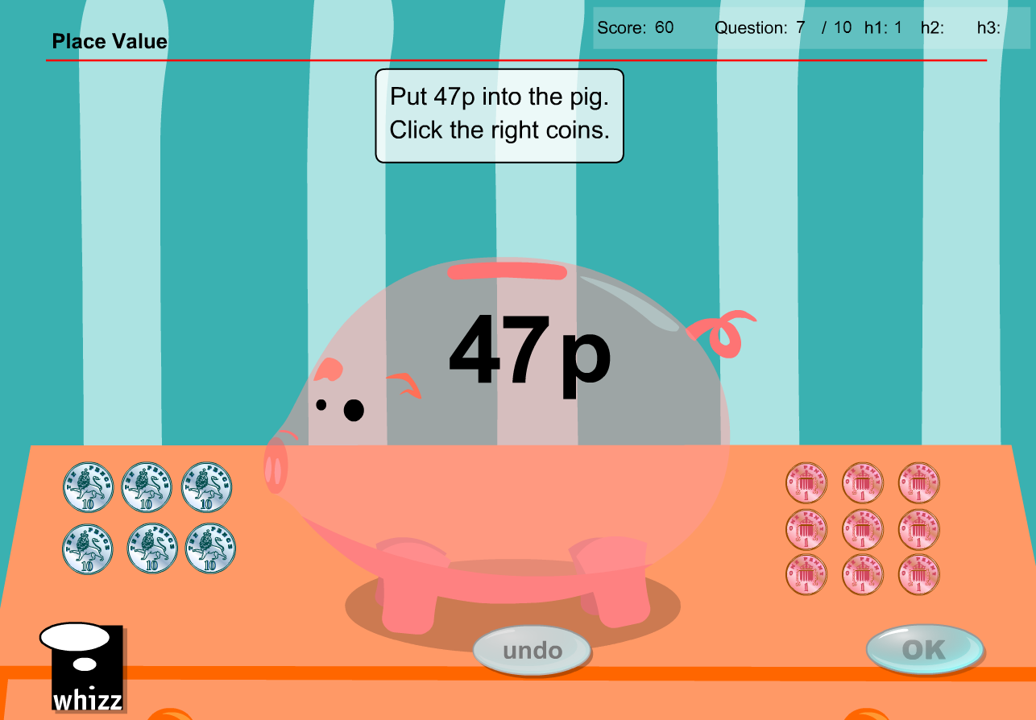

Question 8

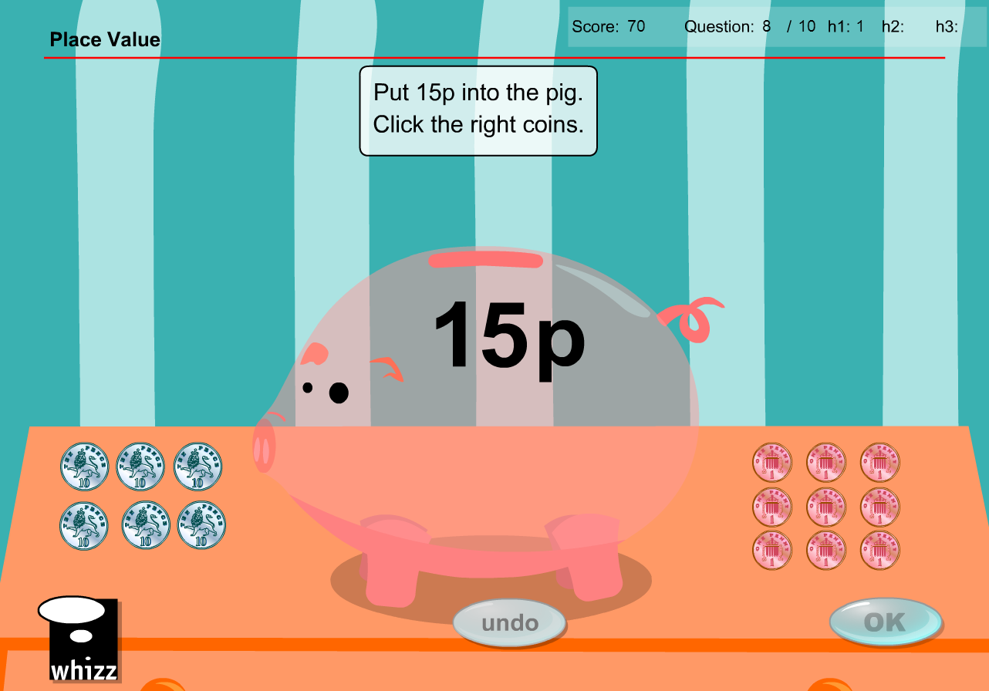

* As per Question 1

Question 9

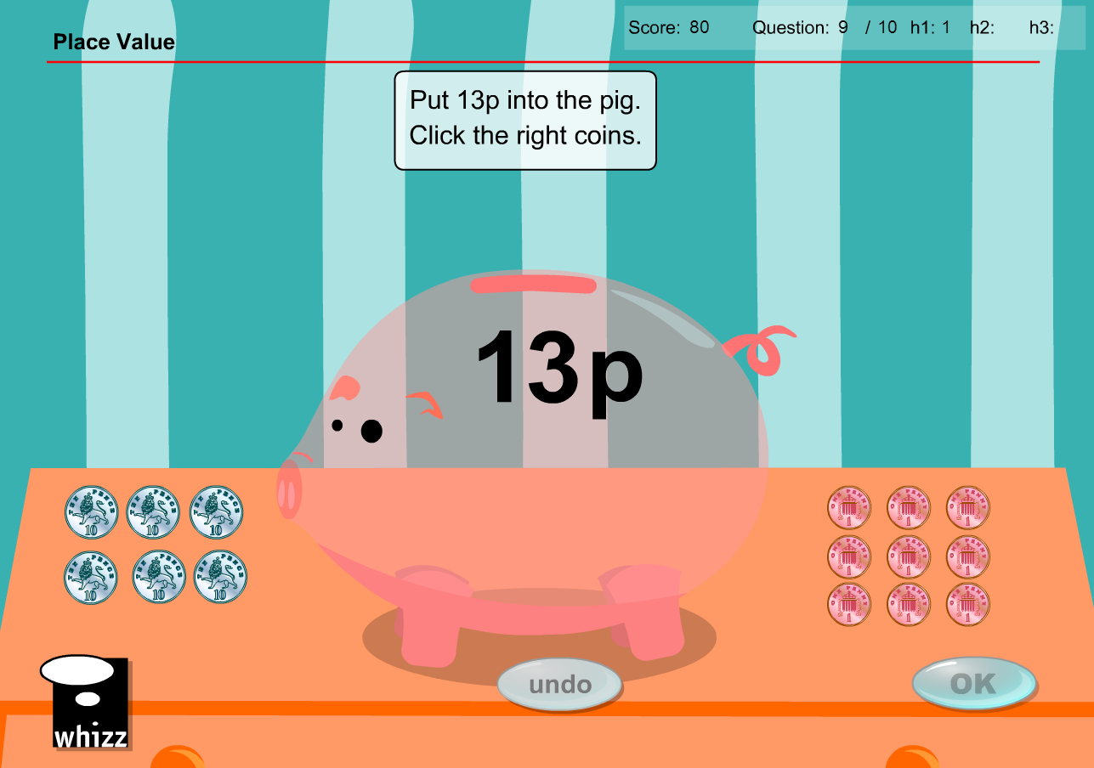

* As per Question 1

Question 10

* As per Question 1

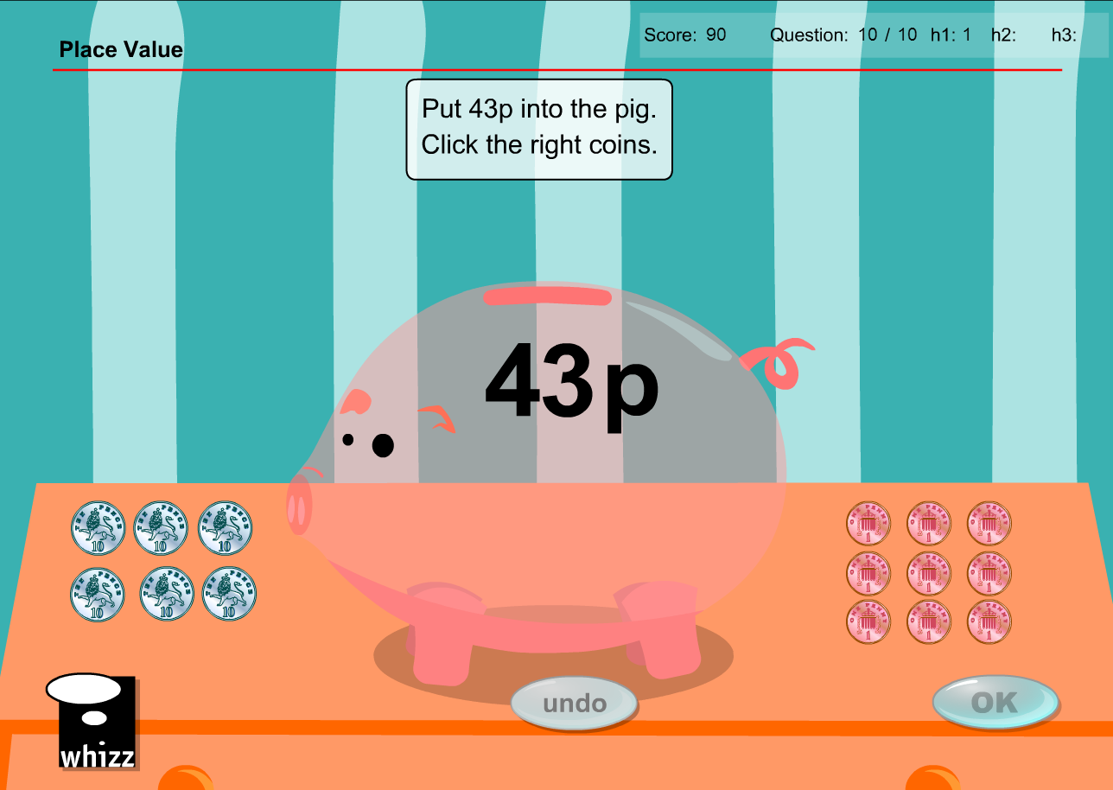

**Test content has the same issues/solution**

All instances of ‘p’ need to be replaced by ‘token(s)’

Question 1

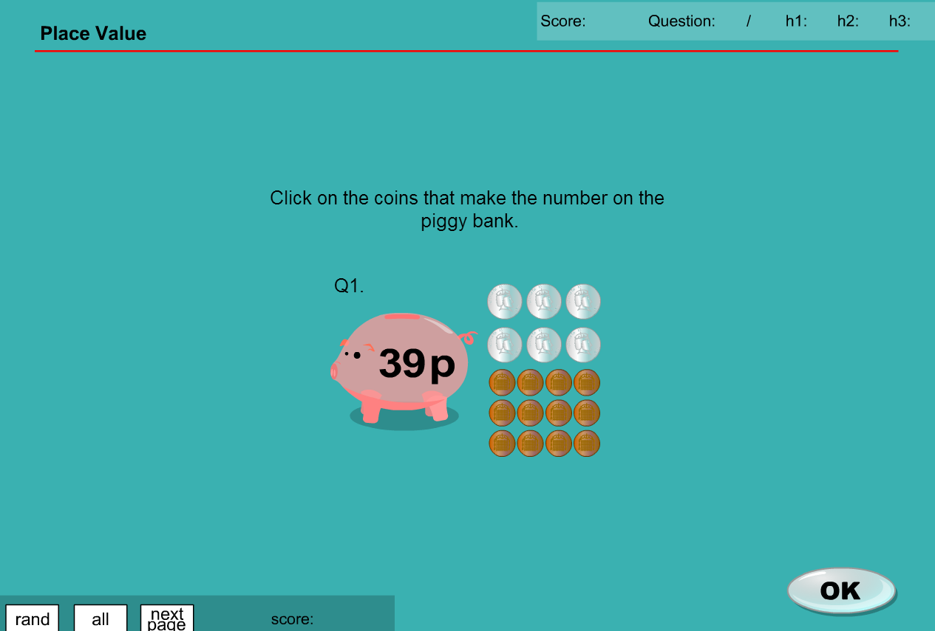

* Use tokens of the same denomination
* Question reworded “Click on the tokens that make the number in the piggy bank.”

Question 2

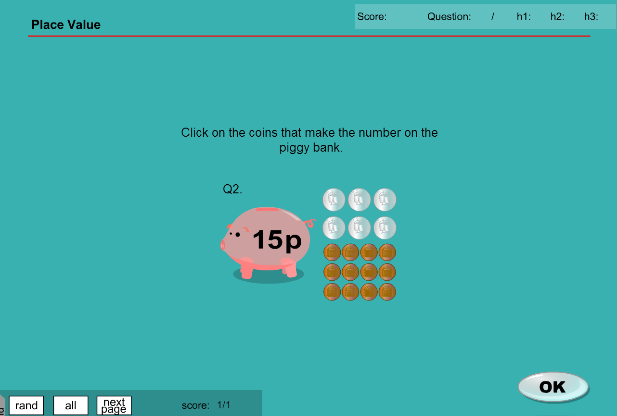

* As per Question 1

Question 3

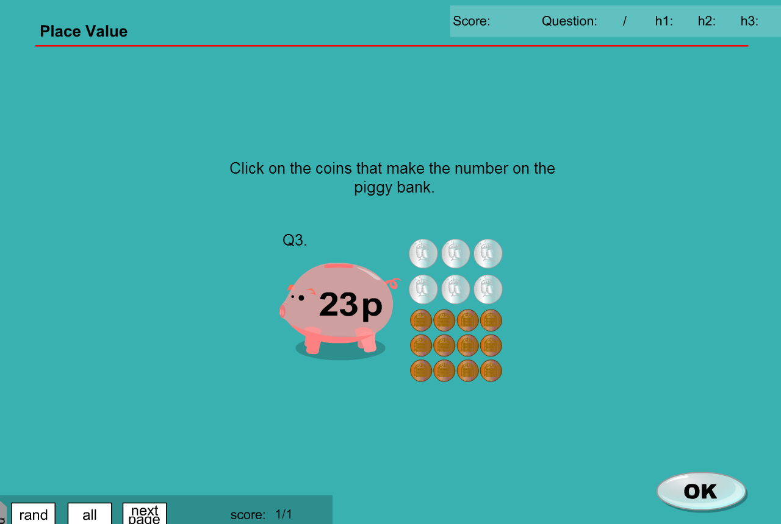

Question 4

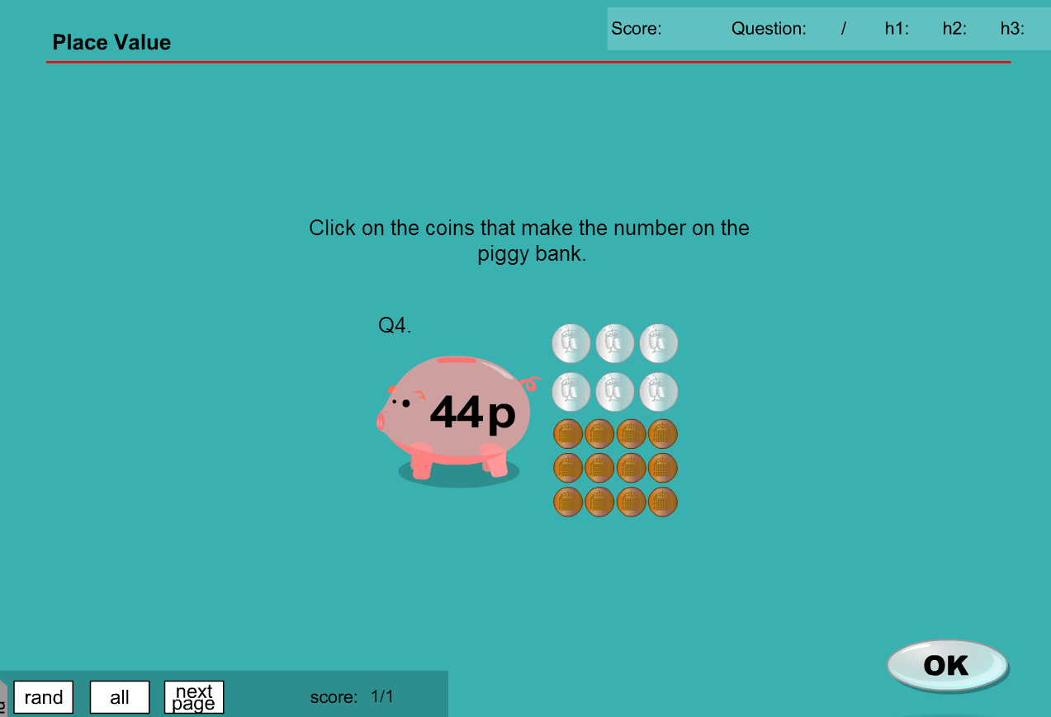

Question 5

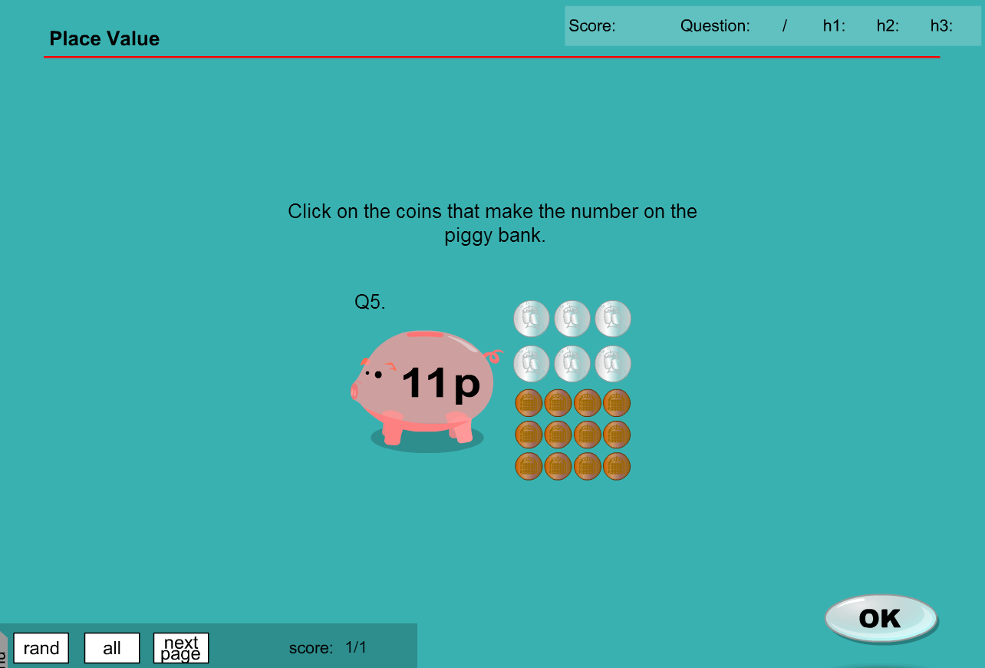

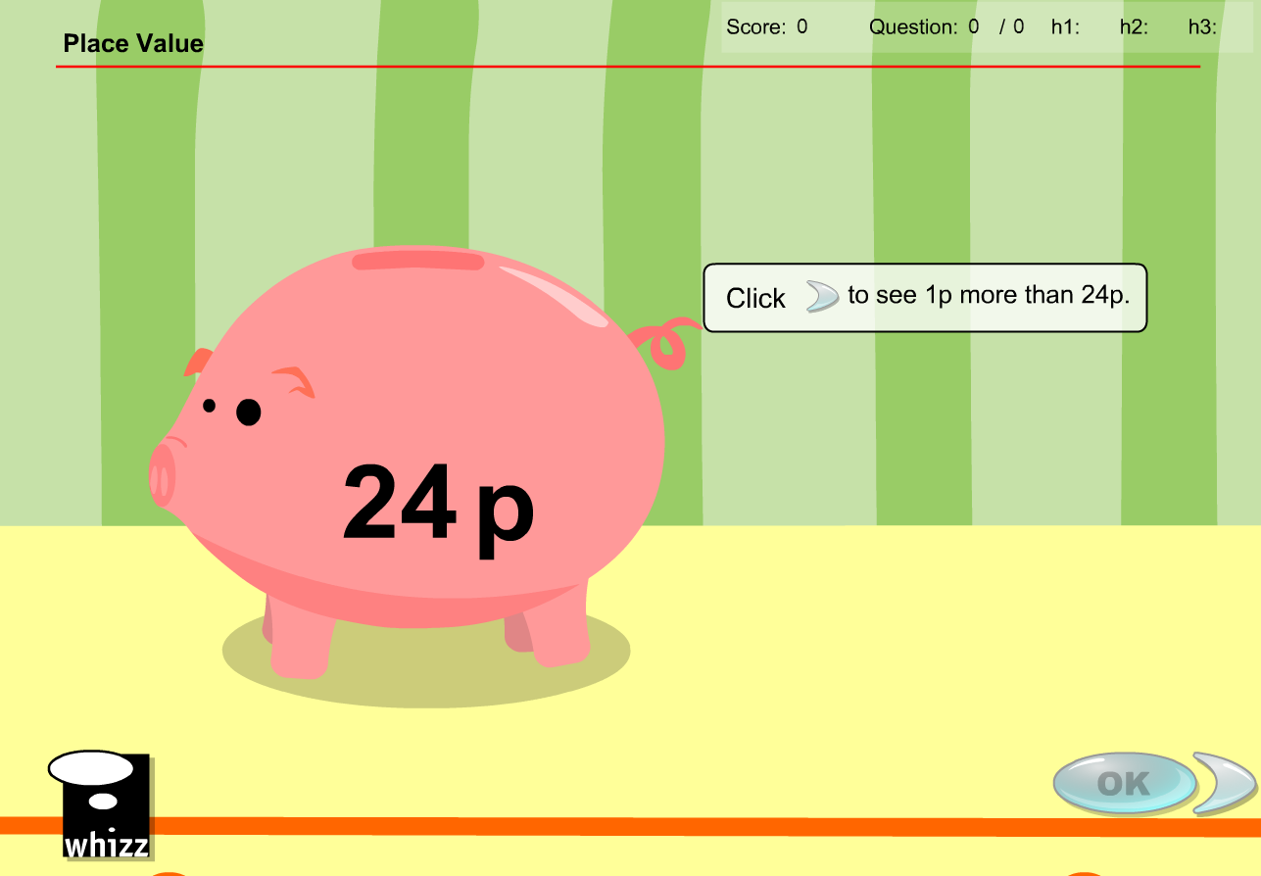

**MA_GBR_0650AAx0500**

Same issues as for MA_GBR_0650AAx0400

Similar issue for the test

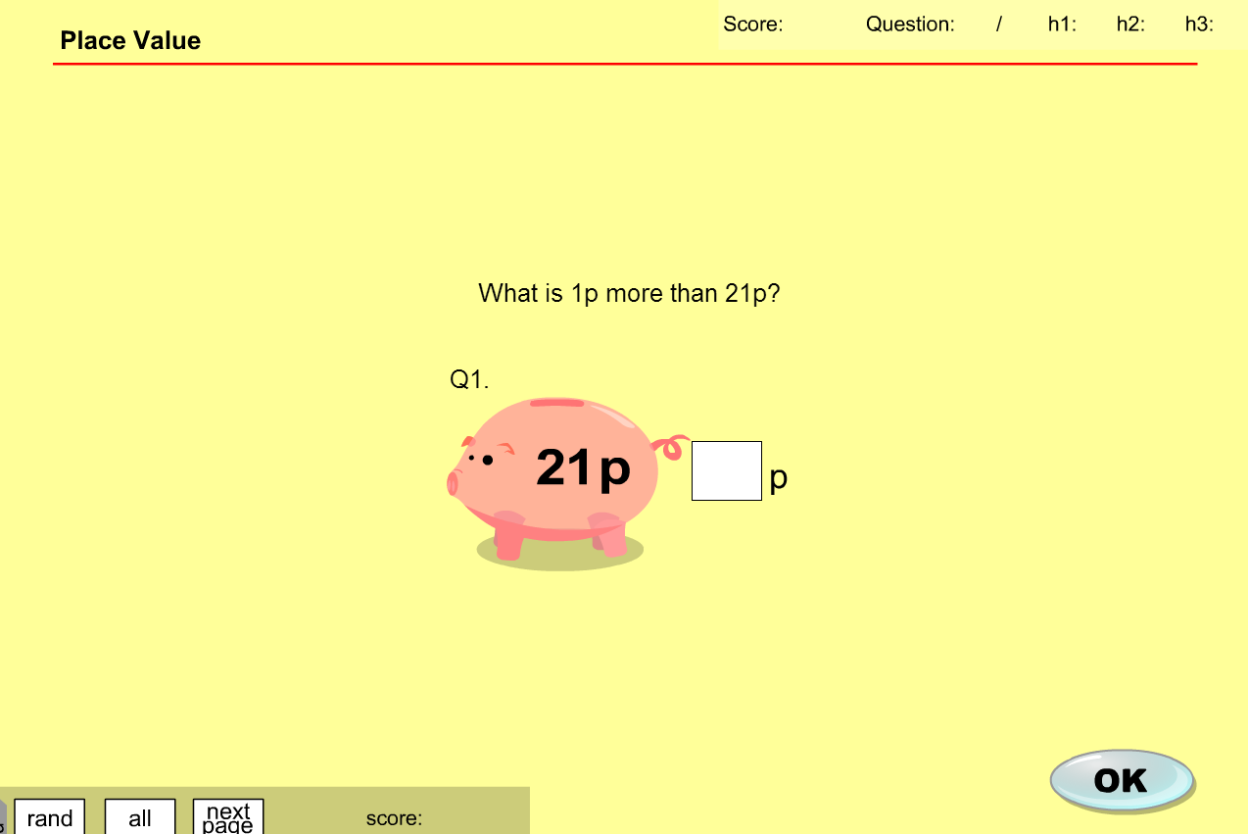

**MA_GBR_0650AAx0500 - fixes**

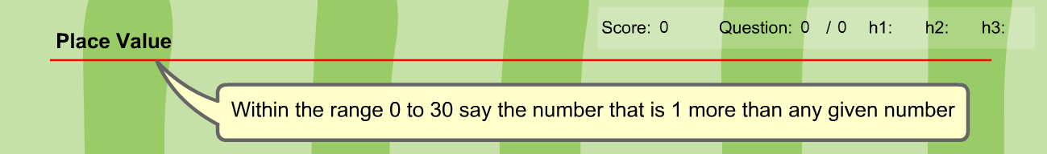

Change ‘p’ into tokens – does not change learning objective

Will require some graphic design creating tokens of same denominations (see example below)

Is the voice over and the sound of the coins a single track or 2 different ones? Voiceover needs to be removed but if coins dropping into pig are a different track then that can remain

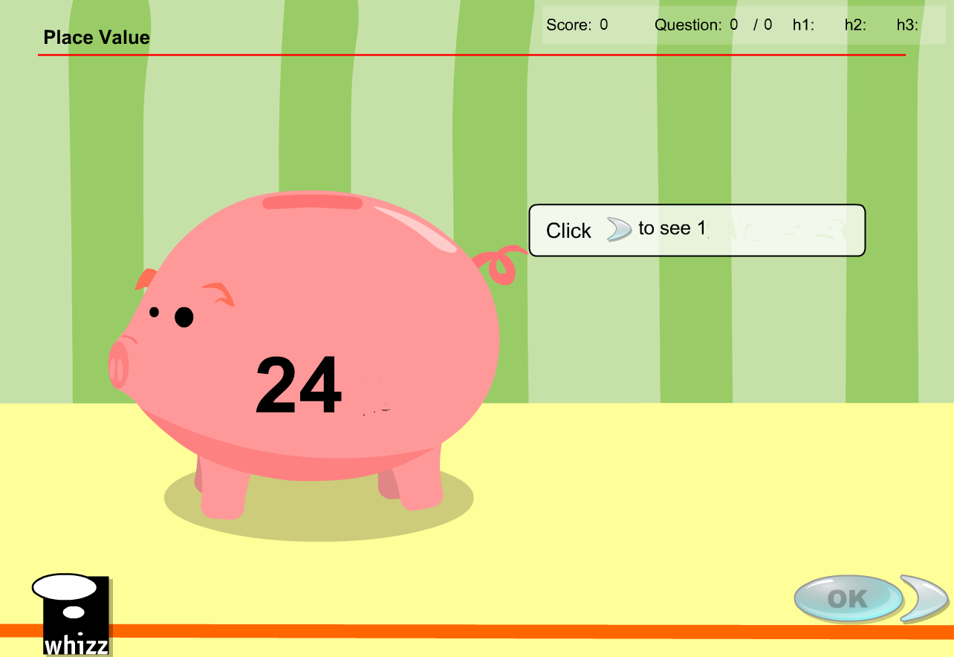

Token more than 24 tokens

**tokens**

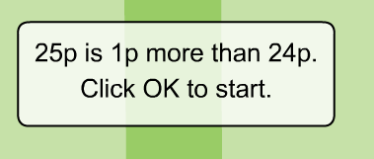 Change to

25 tokens is 1 more than 24 tokens. Click OK to start.

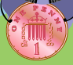

Change to tokens of denominations 1 and 10

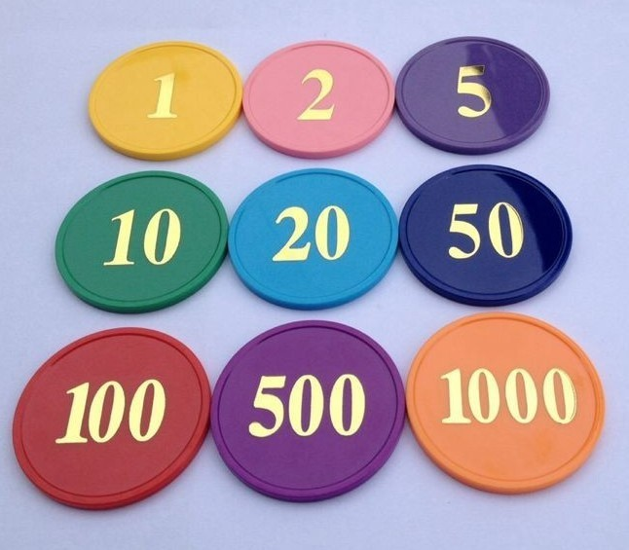

MA_GBR_0650AAx0600

**Exercise Content**

Question 1

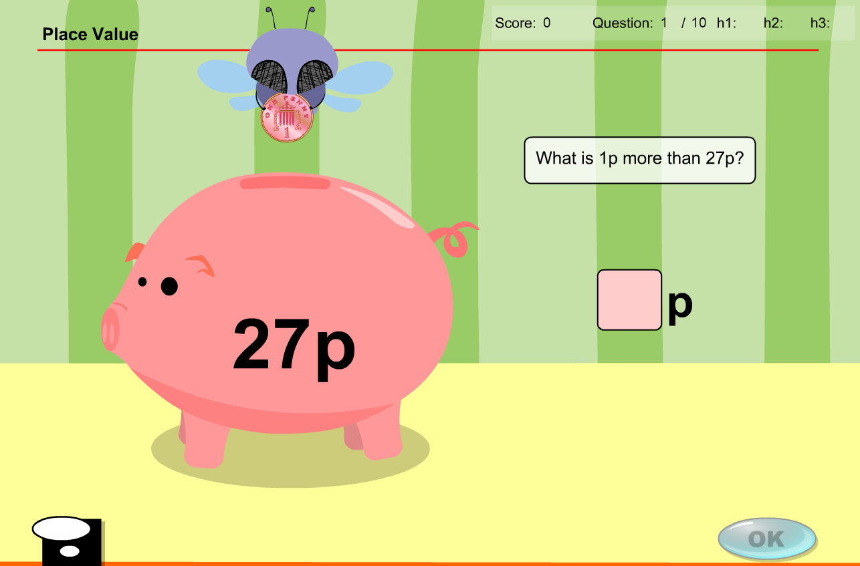

27p replaced by 27 tokens. 1p coin replaced by token denomination 1. Answer box has ‘p’ replaced by ‘tokens’. Initial 10p coins dropping into pig replaced by token denomination 10.

Question 2

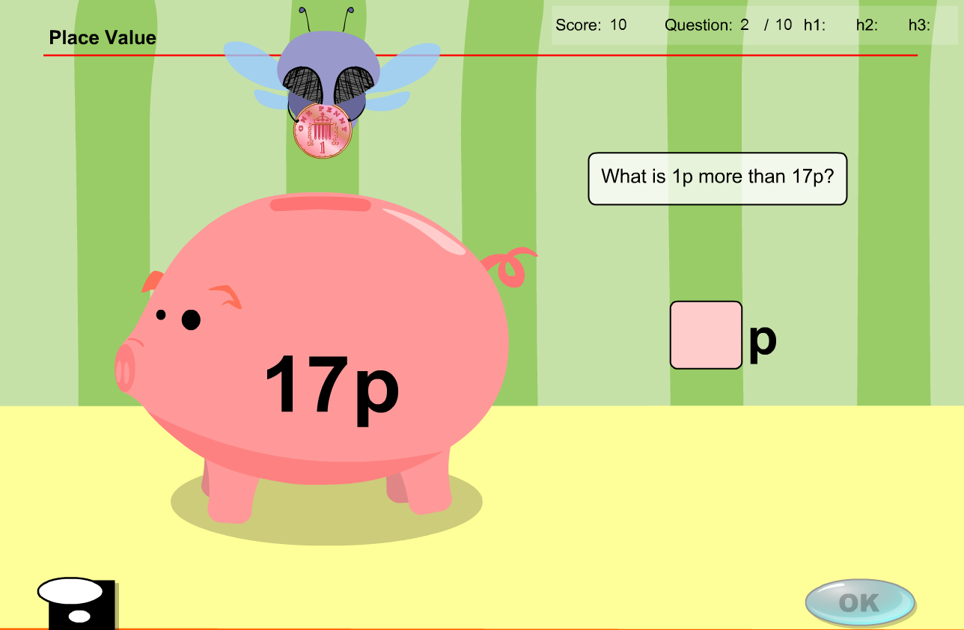

As previously mentioned. All instances of ‘p’ replaced by ‘token(s)’

Question 3

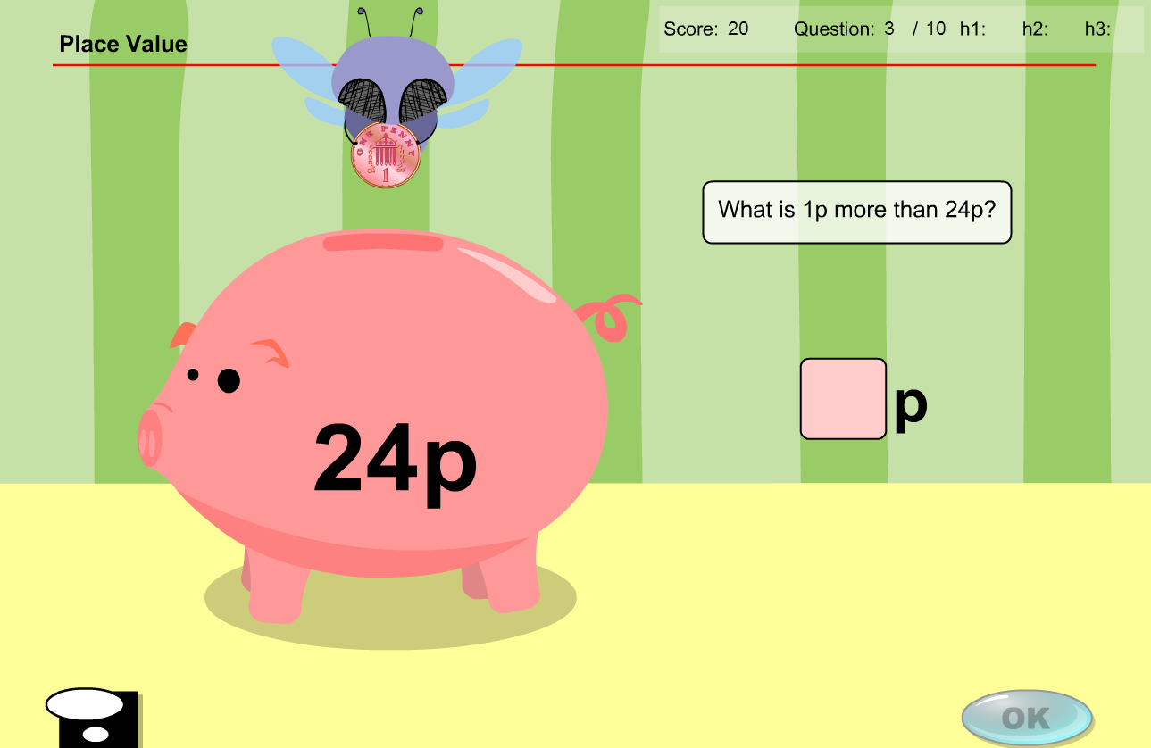

As previously mentioned. All instances of ‘p’ replaced by ‘token(s)’

Question 4

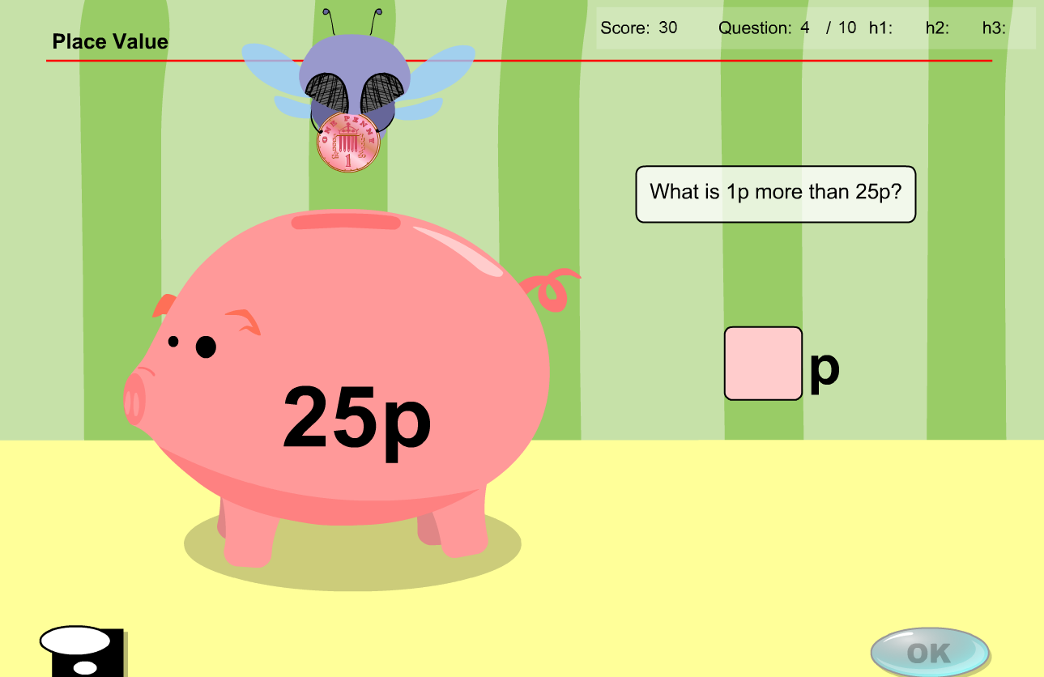

As previously mentioned. All instances of ‘p’ replaced by ‘token(s)’

Question 5

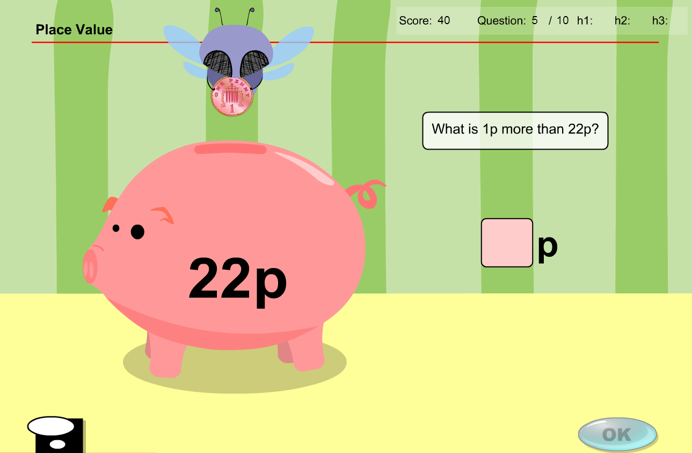

As previously mentioned. All instances of ‘p’ replaced by ‘token(s)’

Question 6

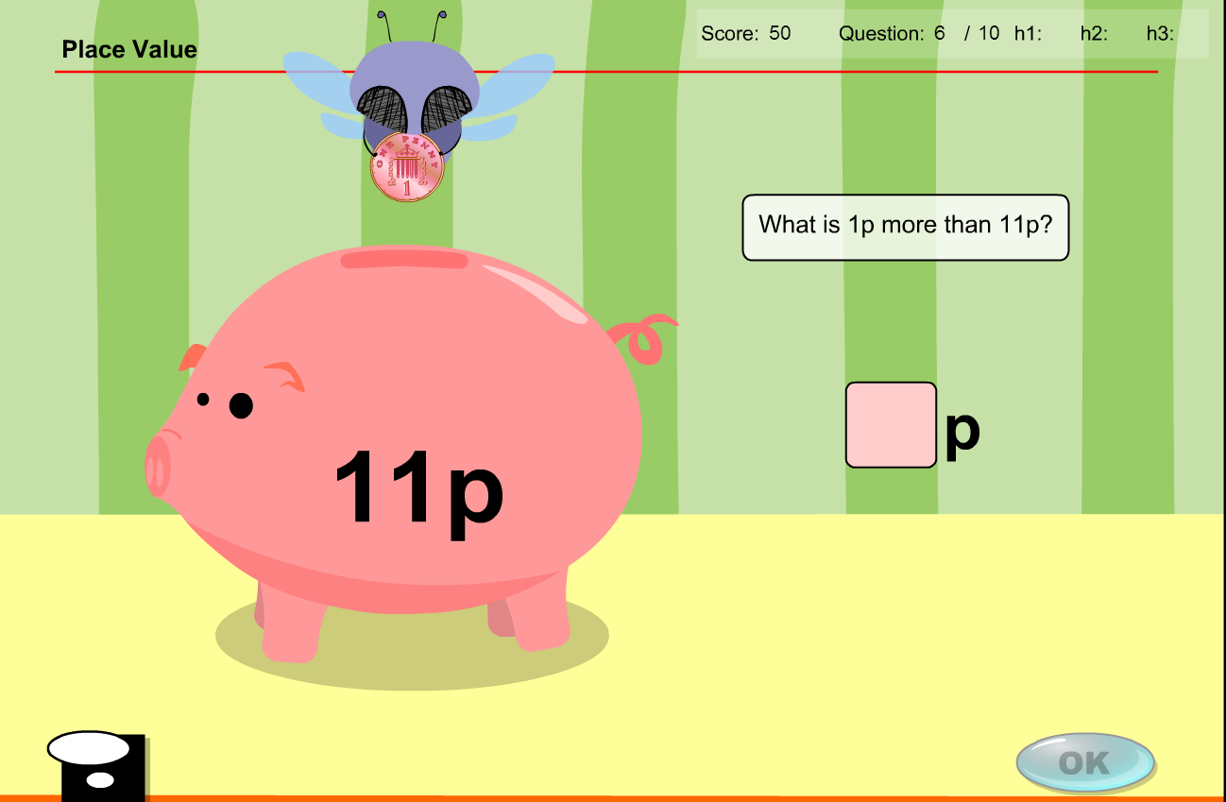

As previously mentioned. All instances of ‘p’ replaced by ‘token(s)’

Question 7

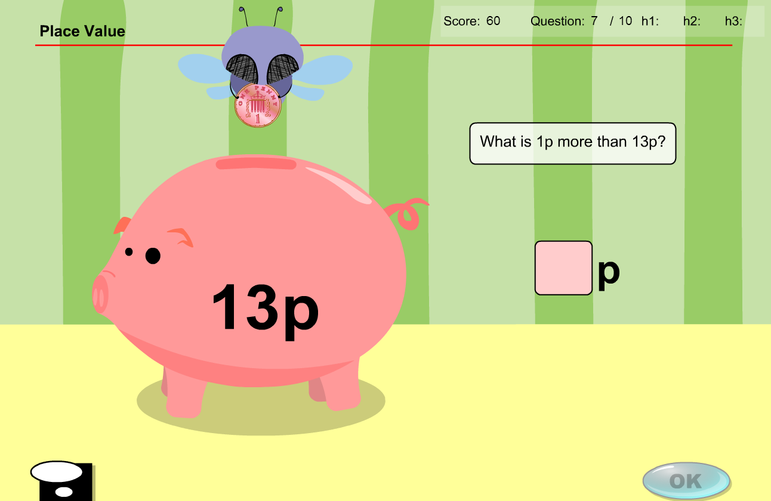

As previously mentioned. All instances of ‘p’ replaced by ‘token(s)’

Question 8

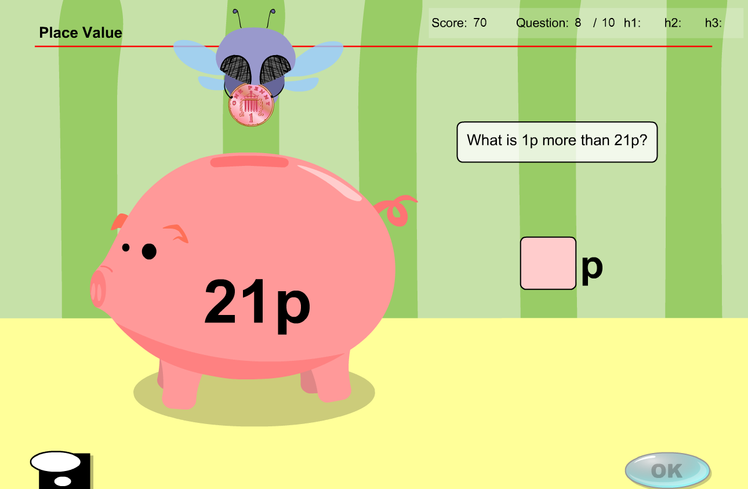

As previously mentioned. All instances of ‘p’ replaced by ‘token(s)’

Question 9

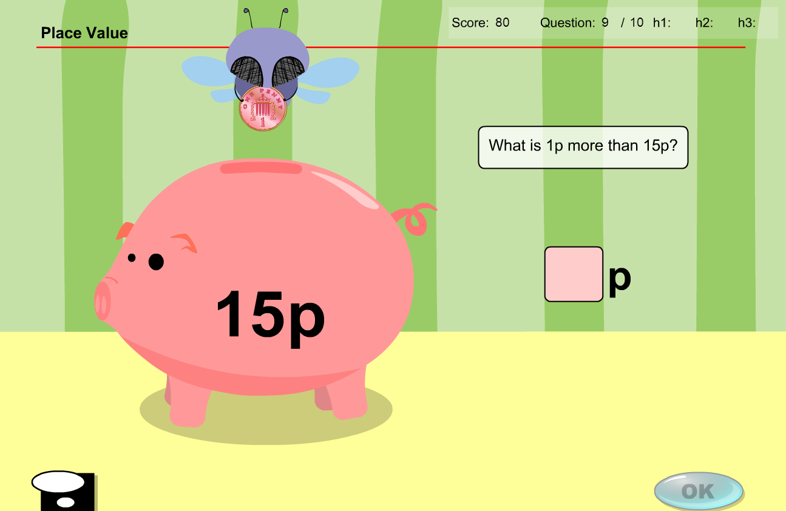

As previously mentioned. All instances of ‘p’ replaced by ‘token(s)’

Question 10

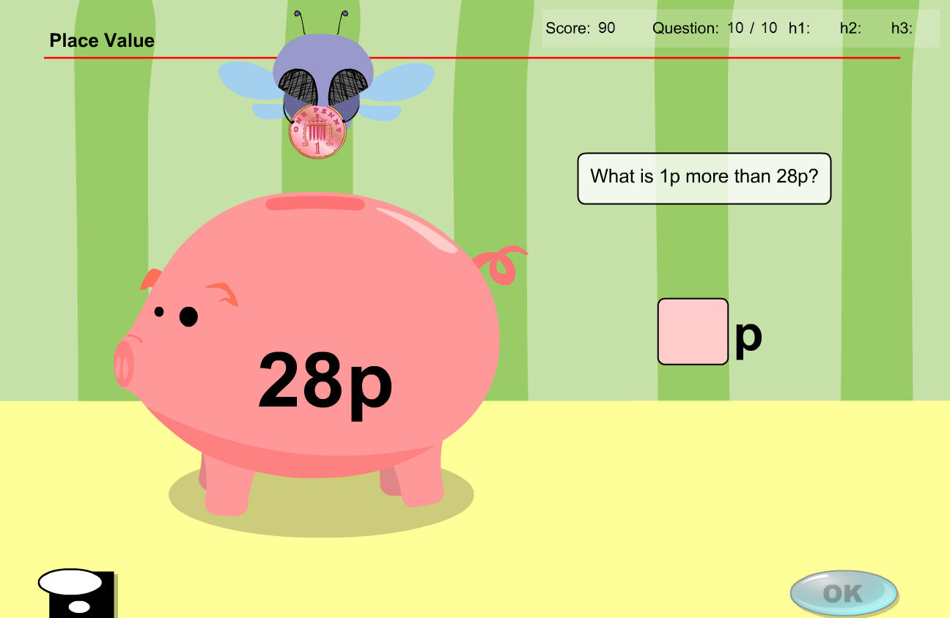

As previously mentioned. All instances of ‘p’ replaced by ‘token(s)’

**Test content has the same issues/solution**

All instances of ‘p’ need to be replaced by ‘token(s)’

Question 1

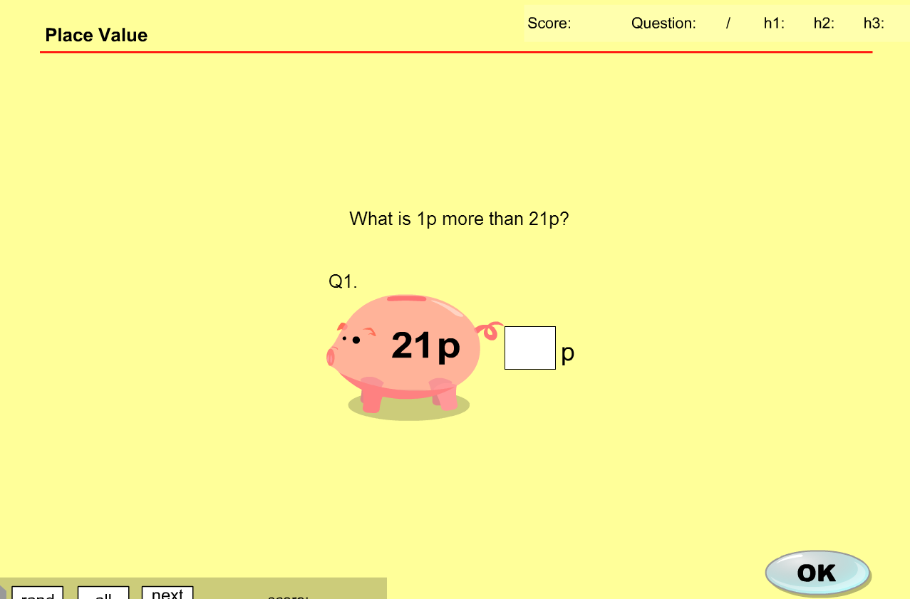

* Change text to read “What is 1 token more than 21 tokens?”

Question 2

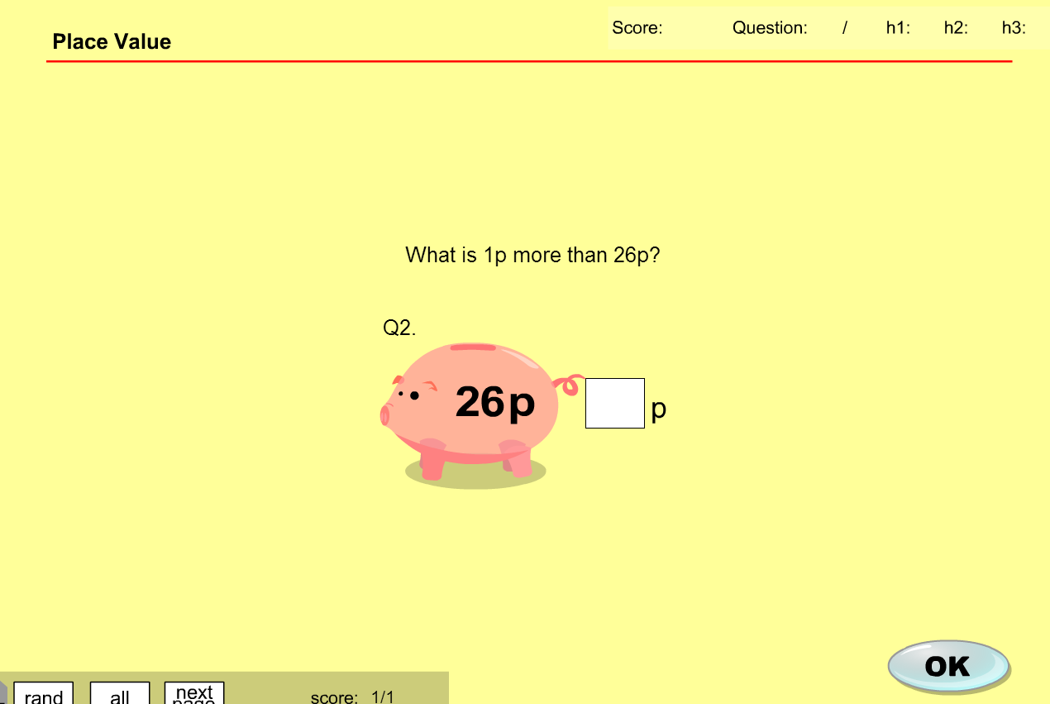

Question 3

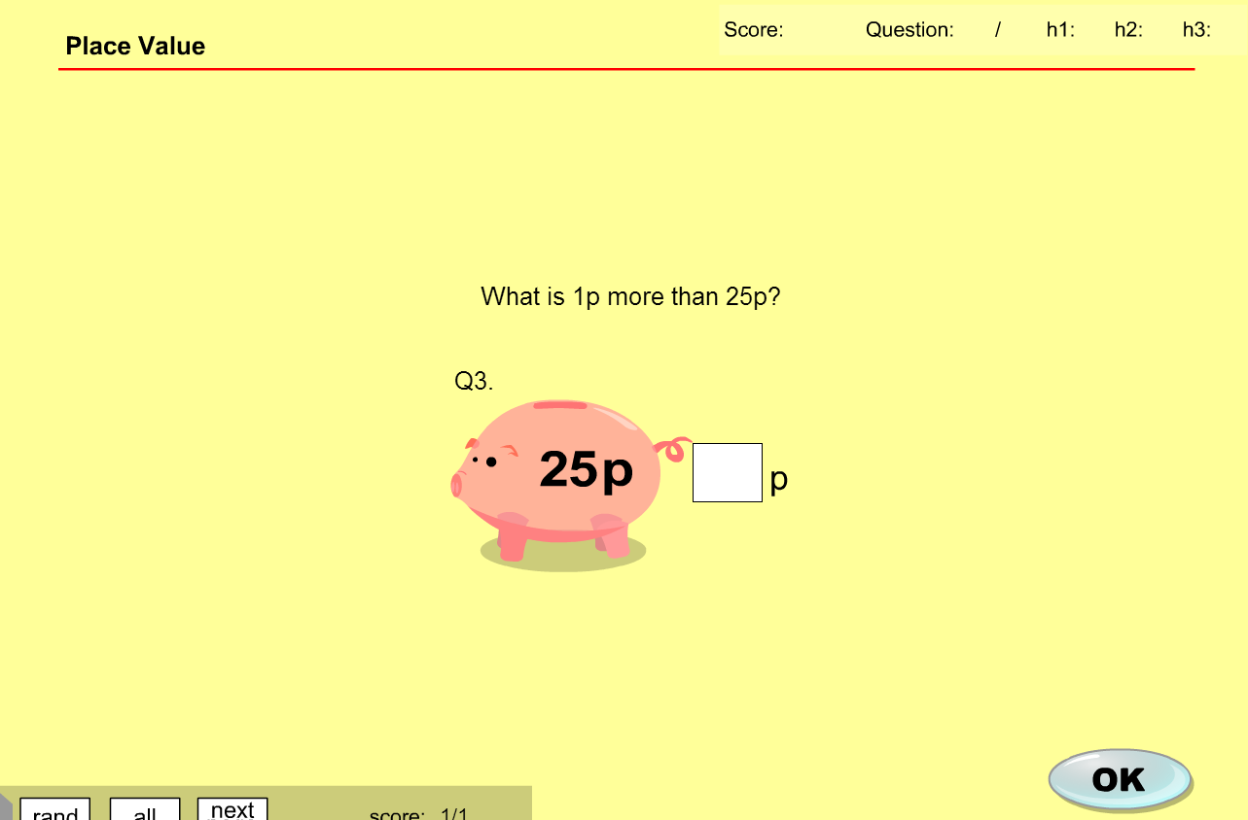

Question 4

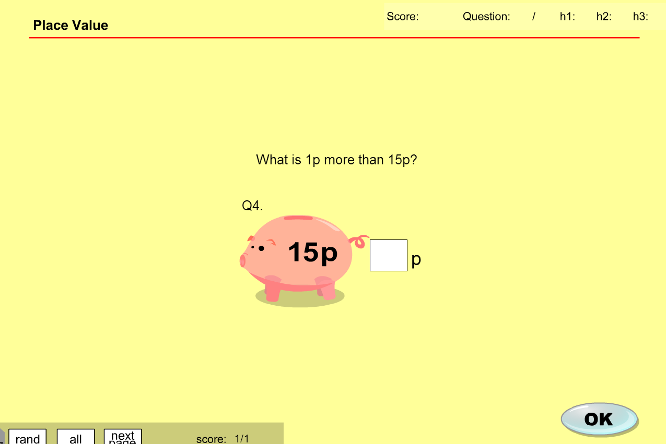

Question 5

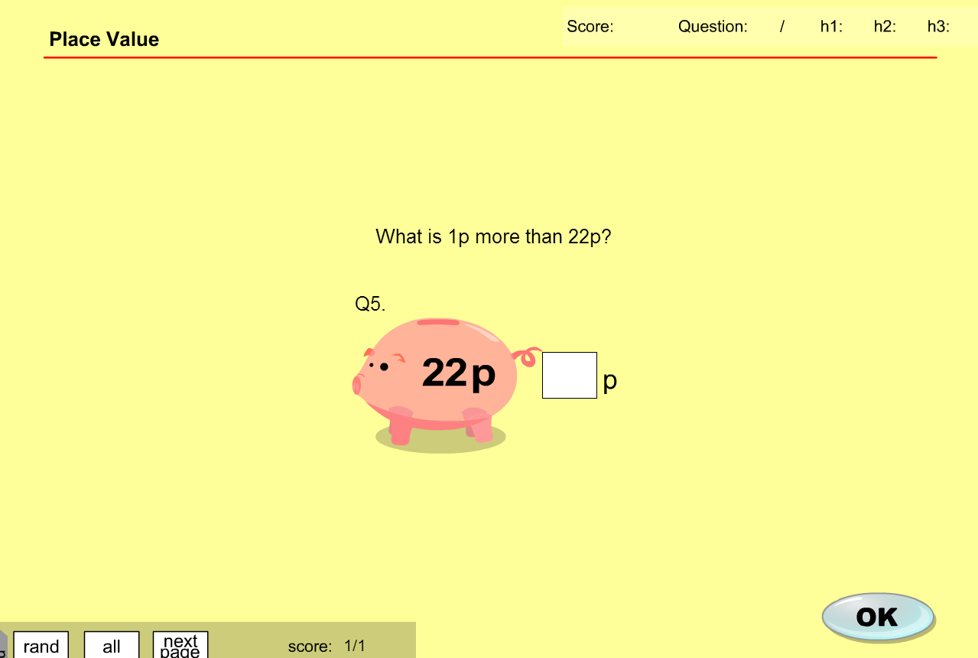

**MA_GBR_0650AAx0600**

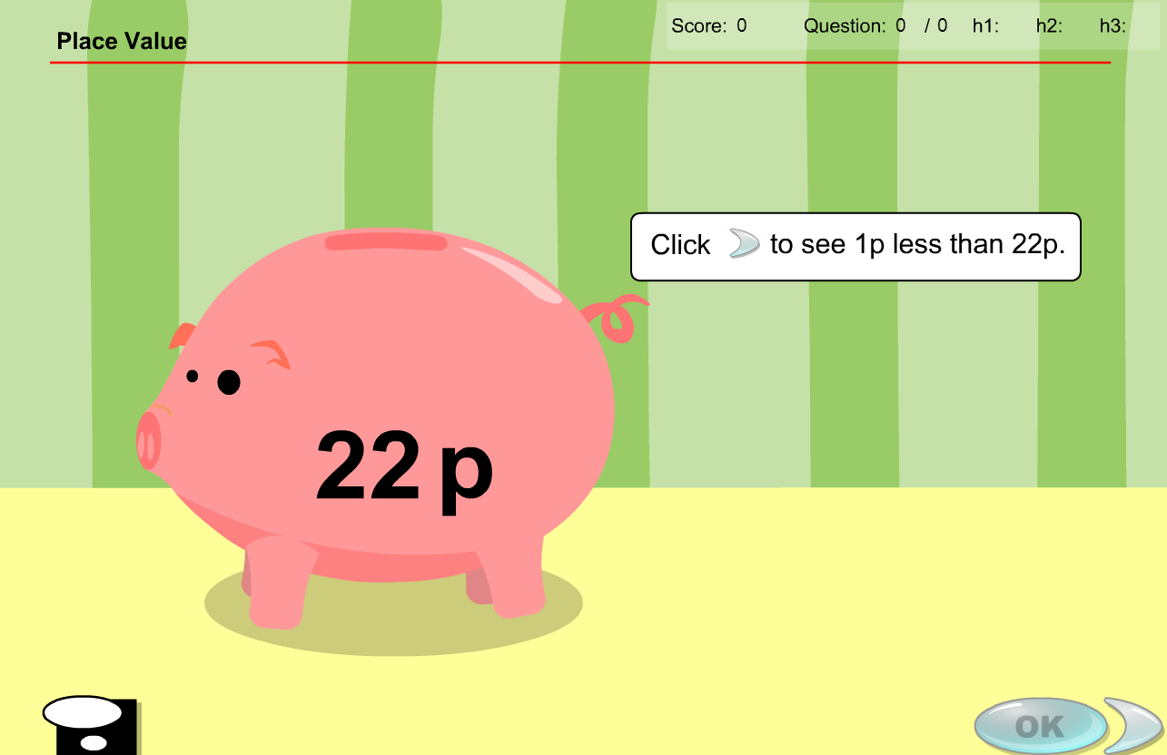

Same issues as for MA_GBR_0650AAx0500

Similar issue for the test

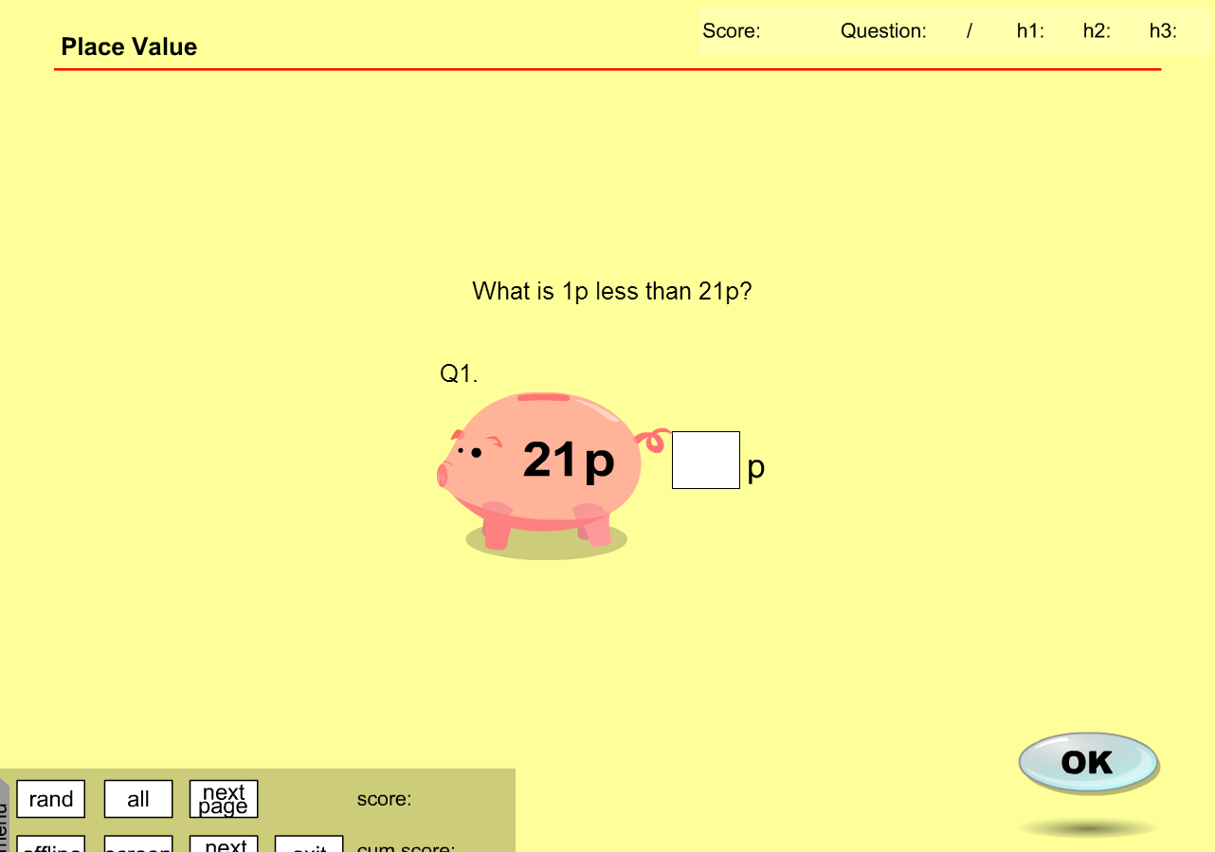

**– fixes**

**MA_GBR_0650AAx0600**

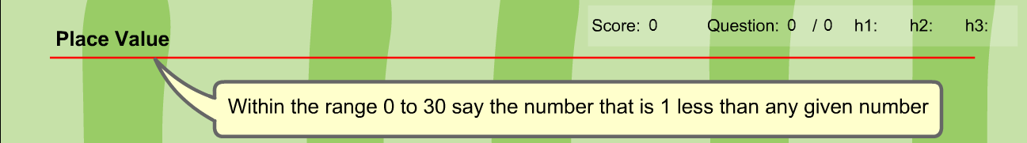

Change ‘p’ into tokens – does not change learning objective

Will require some graphic design creating tokens of same denominations (see example below)

Is the voice over and the sound of the coins a single track or 2 different ones? Voiceover needs to be removed but if coins dropping into pig are a different track then that can remain



Token less than 24 tokens

**tokens**



Change to tokens of denominations 1 and 10



**Exercise Content**

Question 1

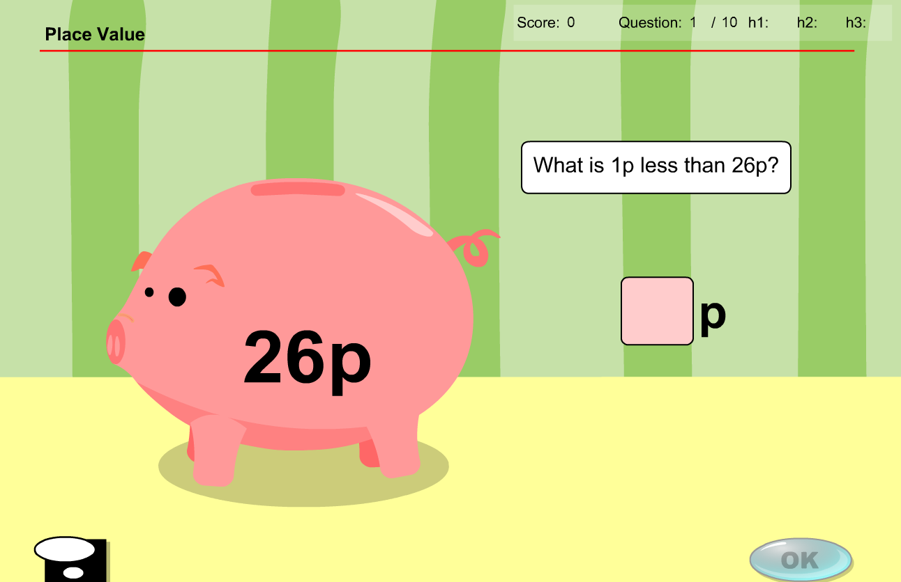

* Change text to read “What is 1 token less than 26 tokens”

26p replaced by 26 tokens. 1p coin replaced by token denomination 1. Answer box has ‘p’ replaced by ‘tokens’. Initial 10p coins dropping into pig replaced by token denomination 10.

Question 2

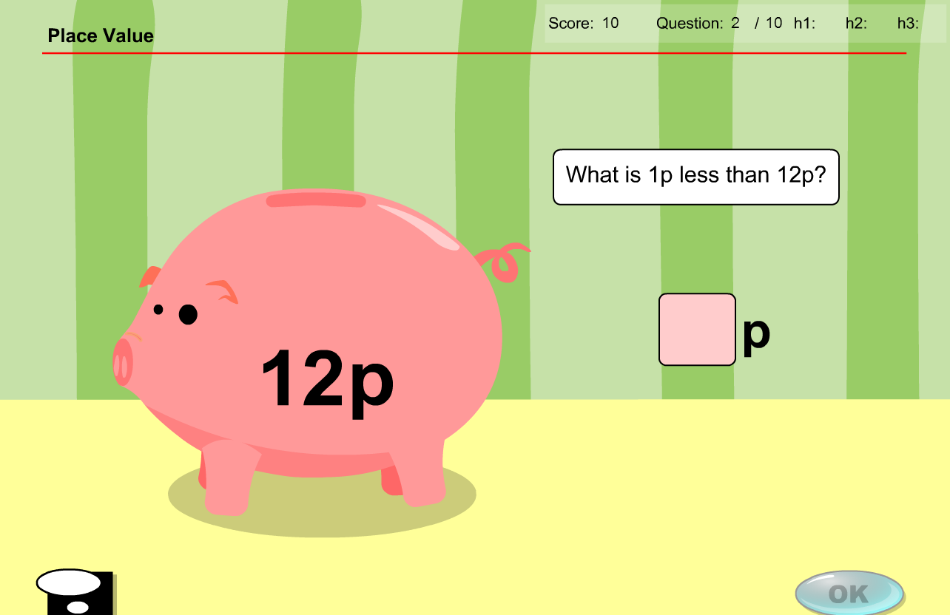

As previously mentioned. All instances of ‘p’ replaced by ‘token(s)’

Question 3

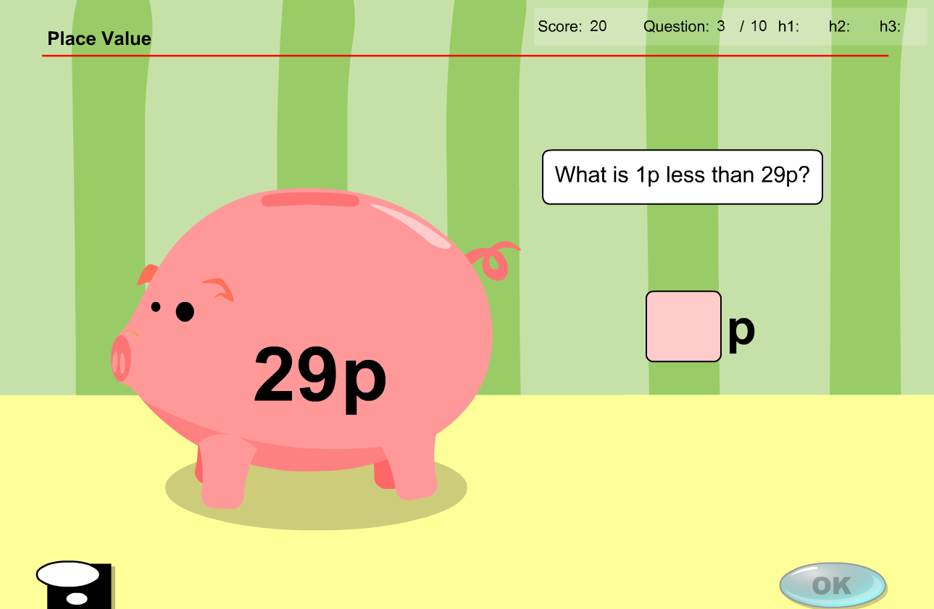

As previously mentioned. All instances of ‘p’ replaced by ‘token(s)’

Question 4

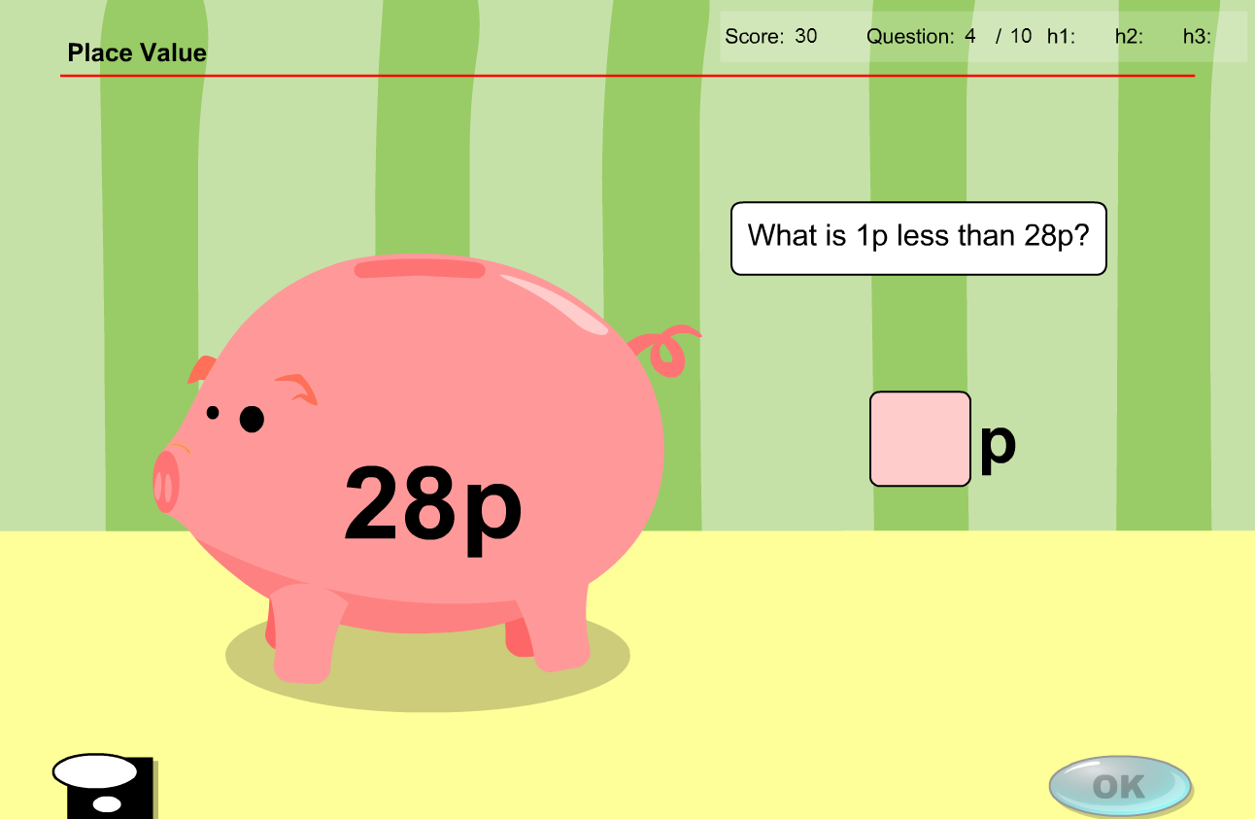

As previously mentioned. All instances of ‘p’ replaced by ‘token(s)’

Question 5

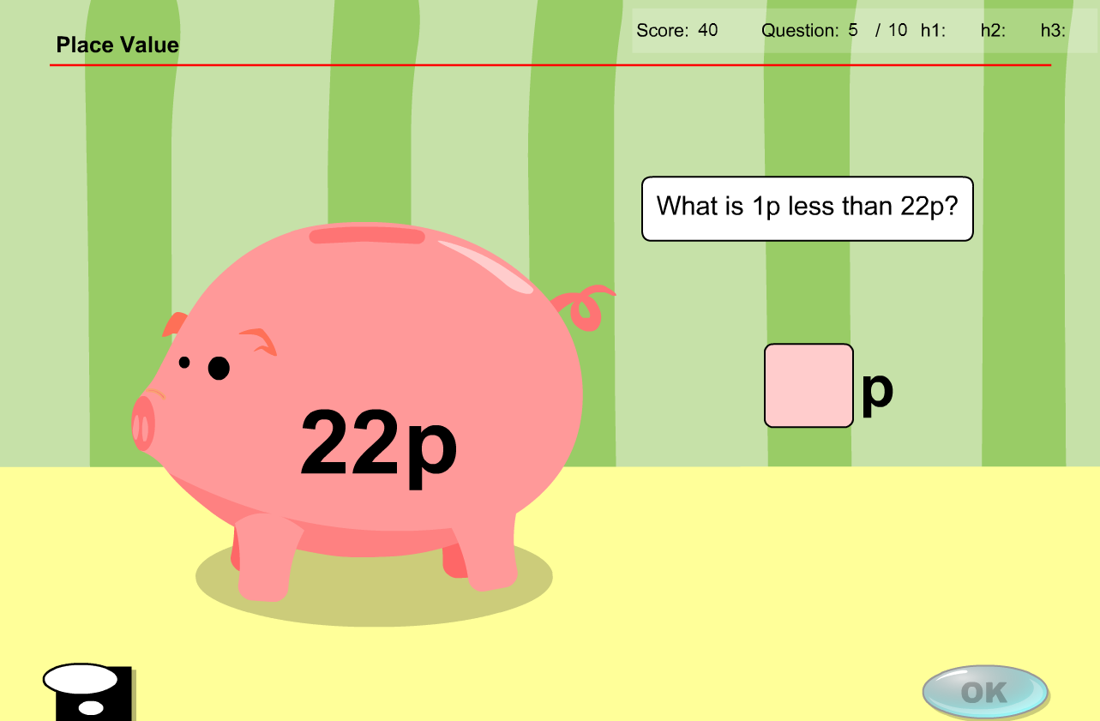

As previously mentioned. All instances of ‘p’ replaced by ‘token(s)’

Question 6

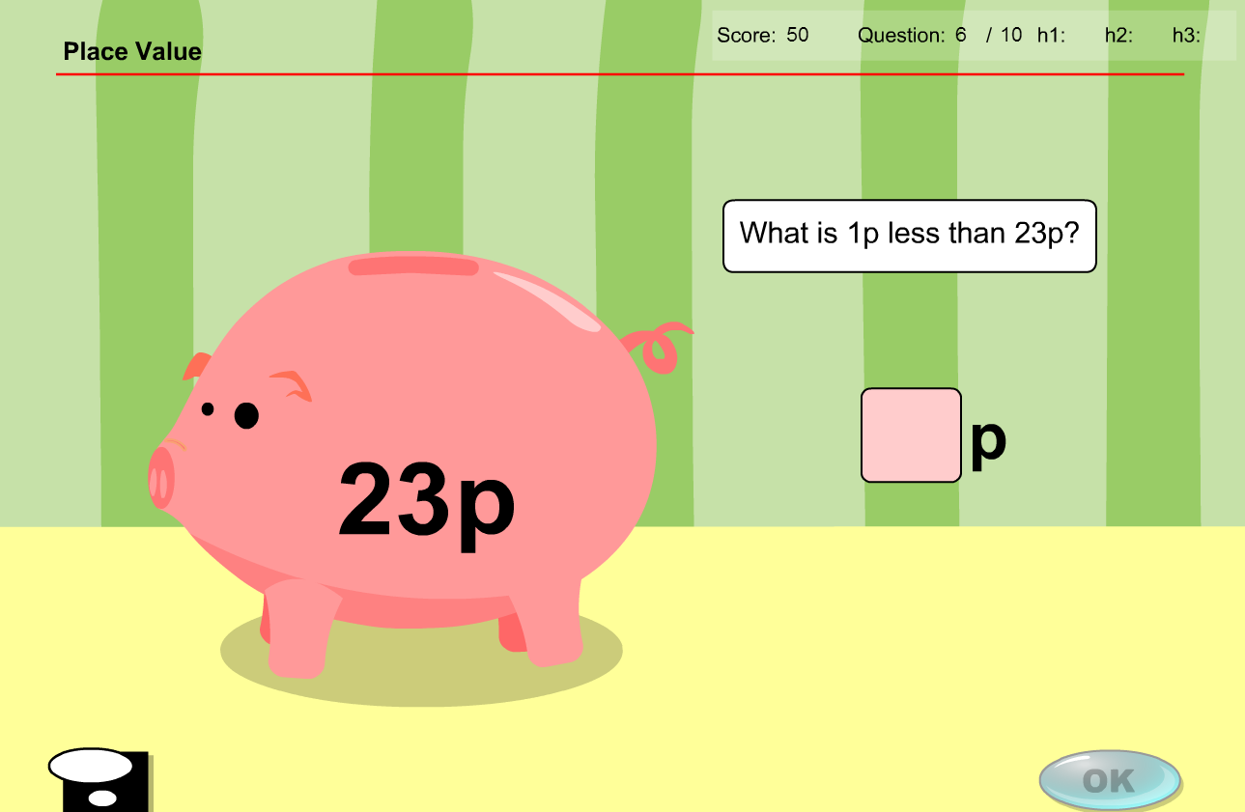

As previously mentioned. All instances of ‘p’ replaced by ‘token(s)’

Question 7

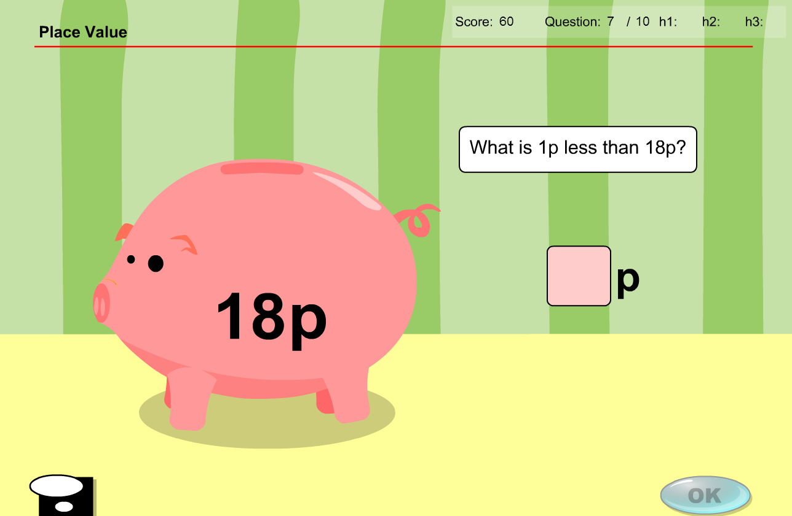

As previously mentioned. All instances of ‘p’ replaced by ‘token(s)’

Question 8

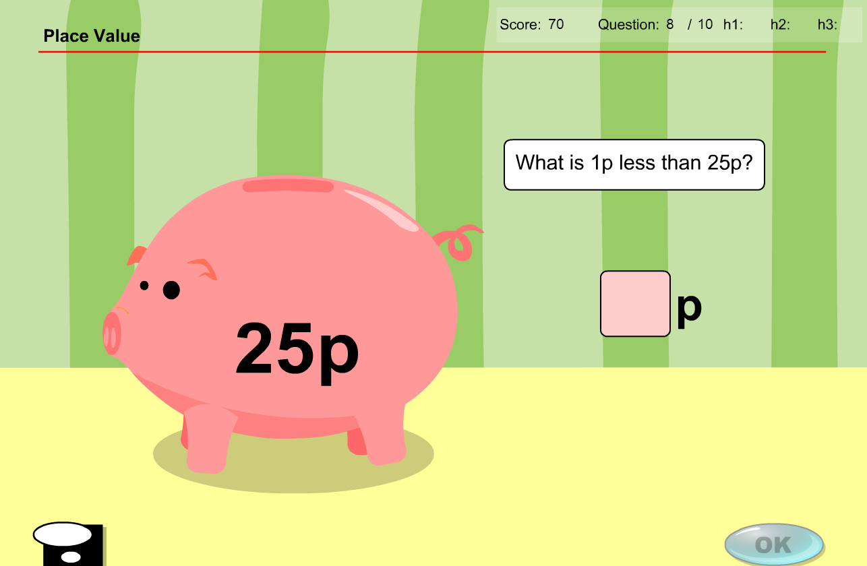

As previously mentioned. All instances of ‘p’ replaced by ‘token(s)’

Question 9

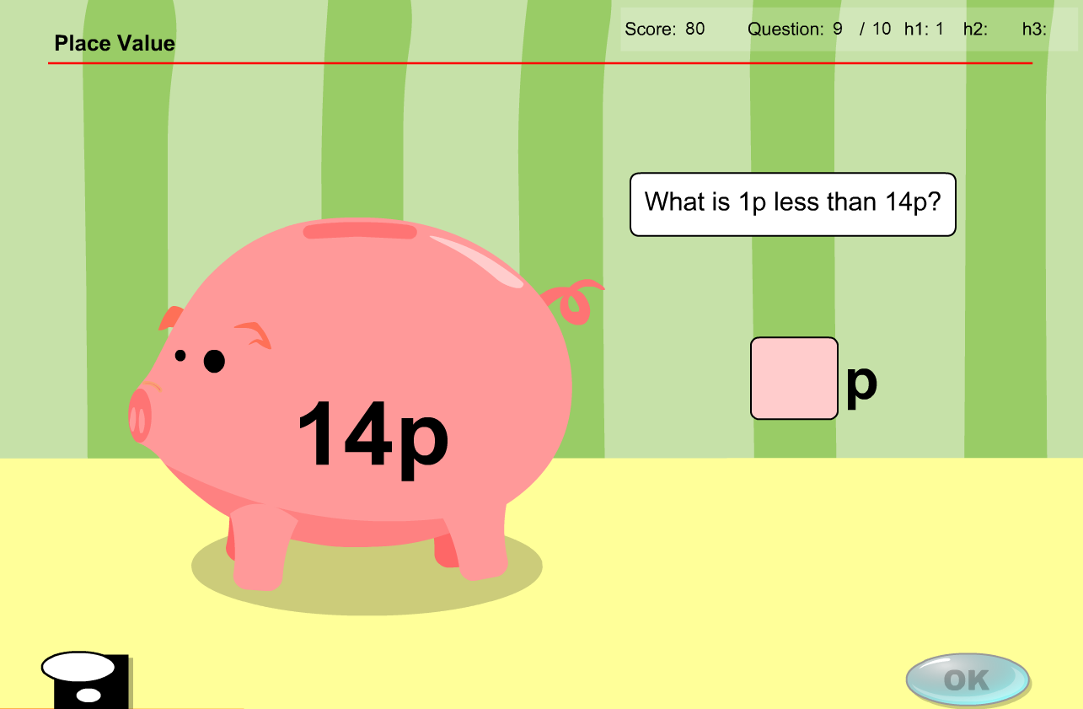

As previously mentioned. All instances of ‘p’ replaced by ‘token(s)’

Question 10

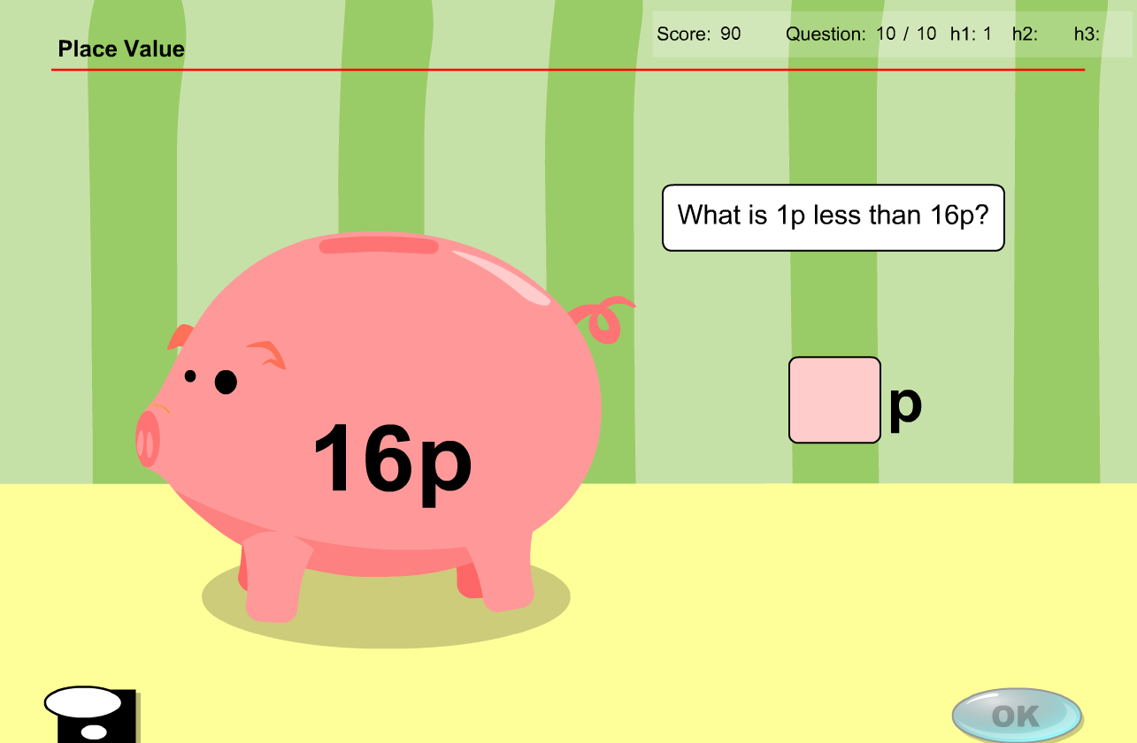

As previously mentioned. All instances of ‘p’ replaced by ‘token(s)’

**Test content has the same issues/solution**

All instances of ‘p’ need to be replaced by ‘token(s)’

Question 1

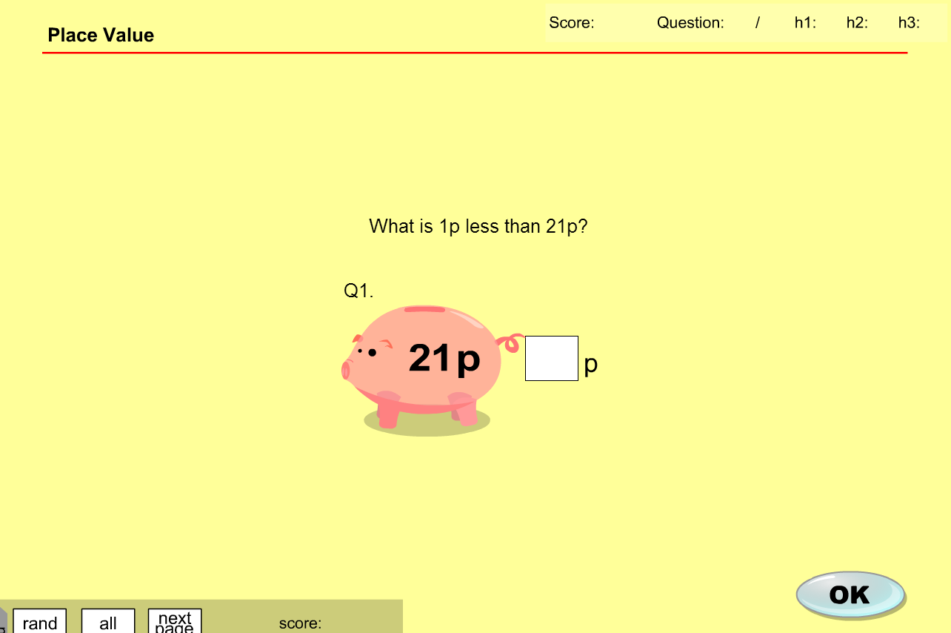

* Change text to read “What is 1 token less than 21 tokens?”

Question 2

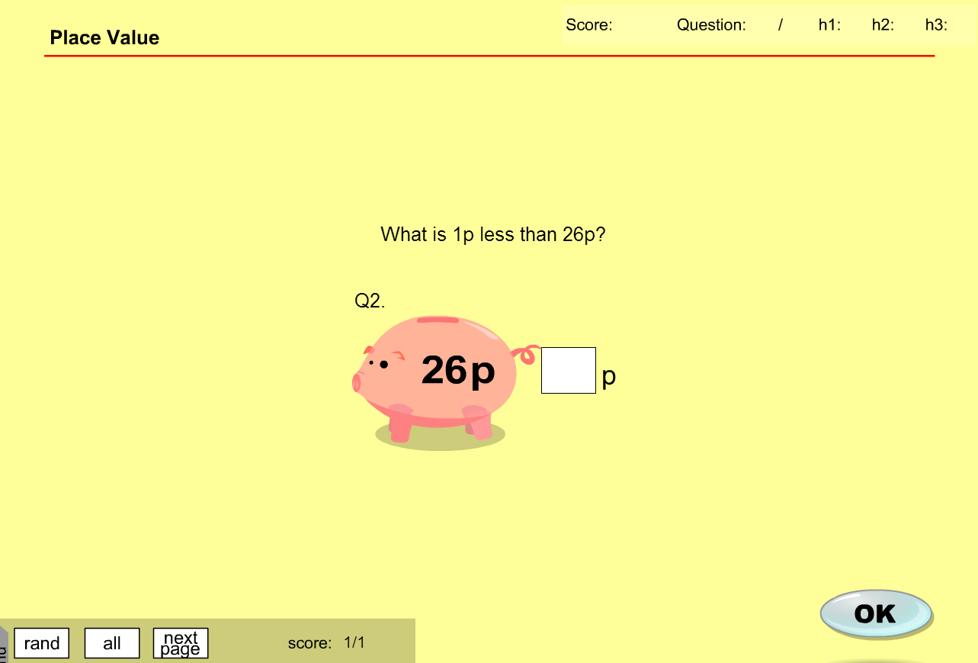

Question 3

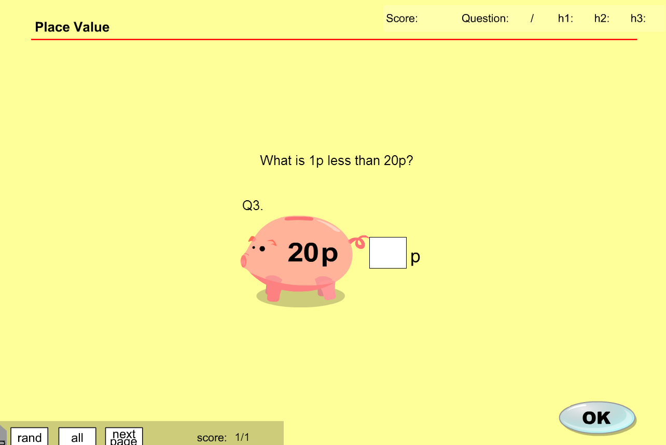

Question 4

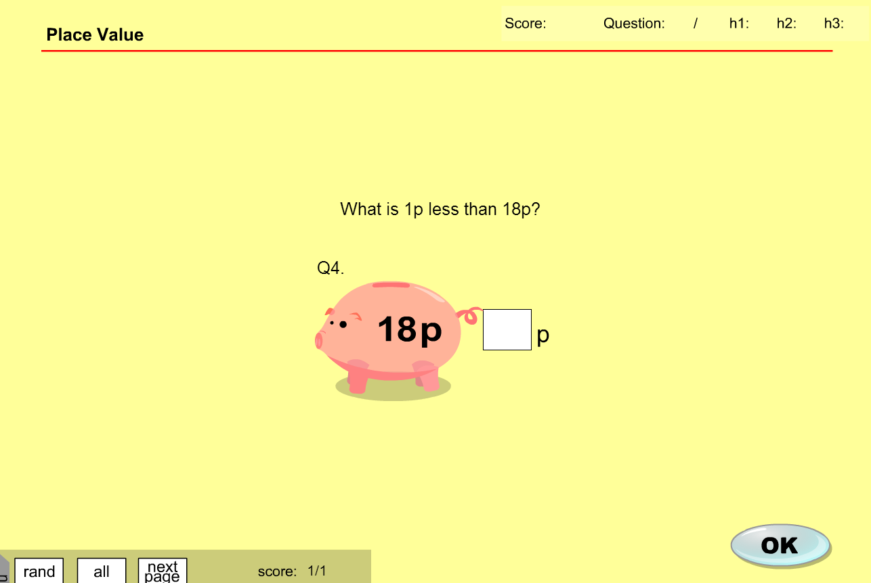

Question 5

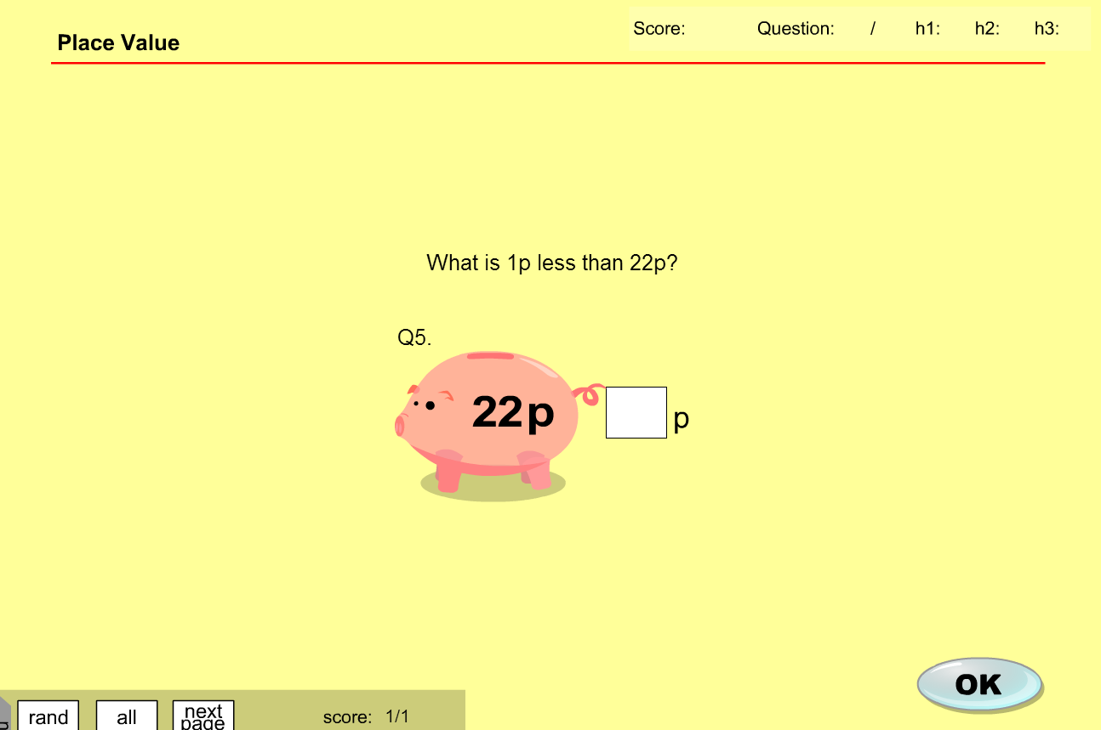

**MA_GBR_0550NAx0300**

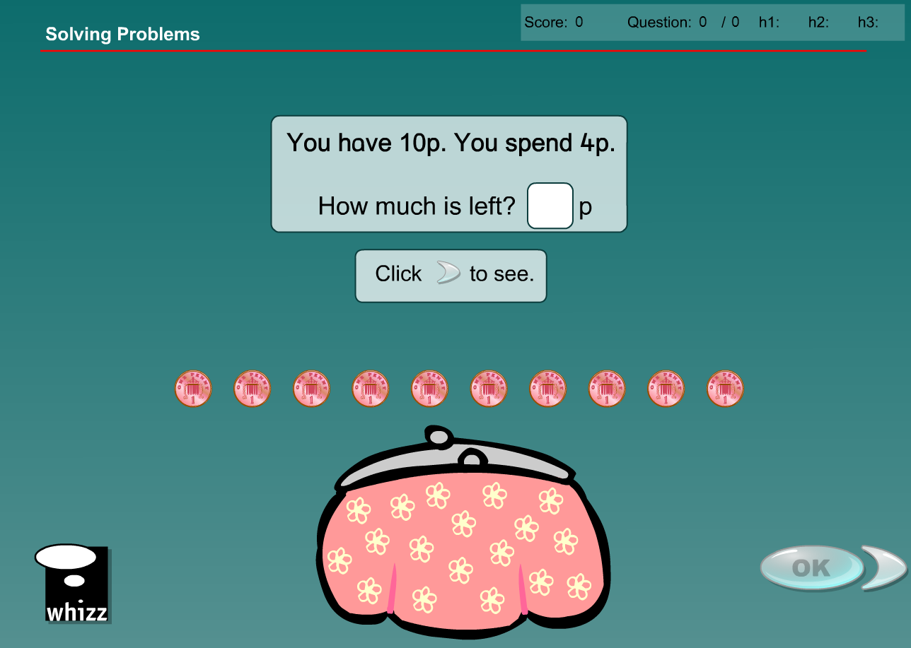

No NZ 1c coin so complete content change required as substituting with coins of different denominations would produce different answers

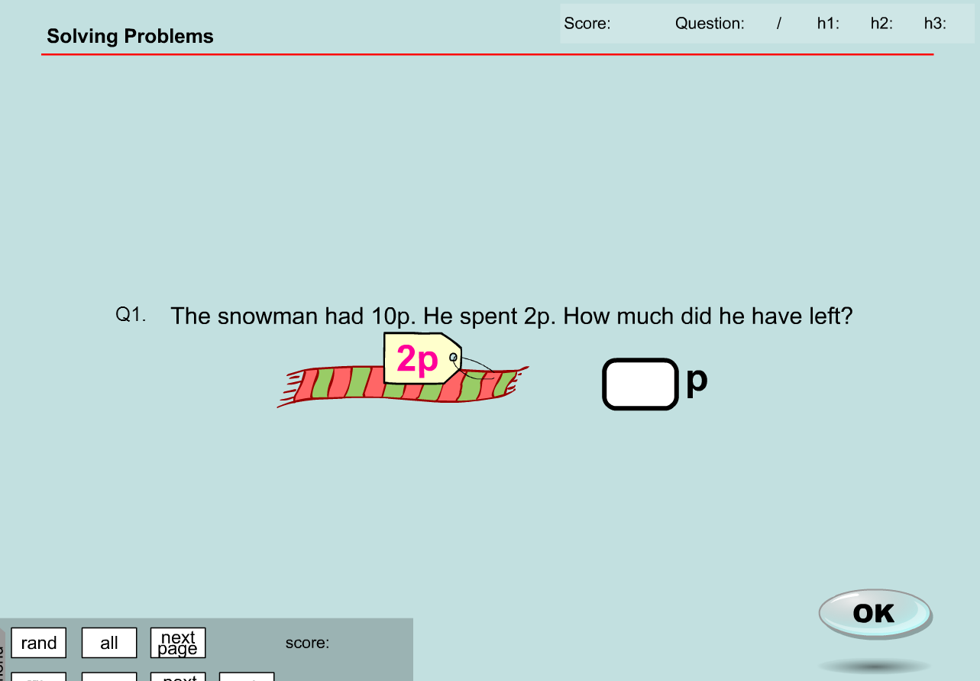

**MA_GBR_0550NAx0300– fixes**

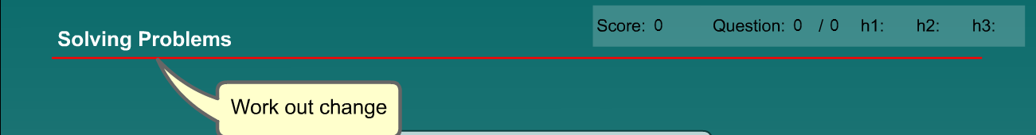

Working out change does not have to be limited to 1p/1c denominations. Localisation achieved by increasing all denominations in question and answer by a factor of 10 and changing ‘p’ to ‘c’.

Voiceover needs removal.

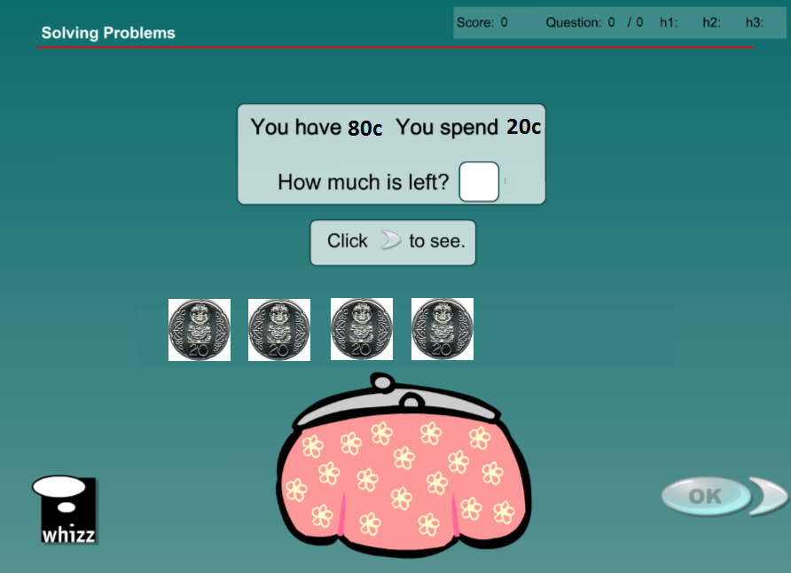

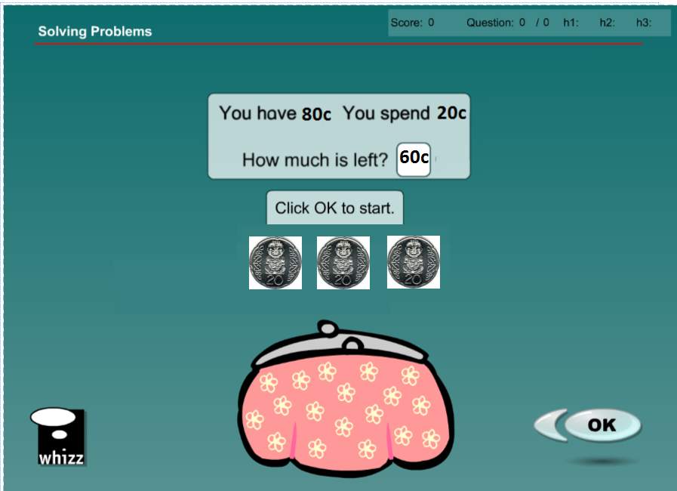

Exercise 1

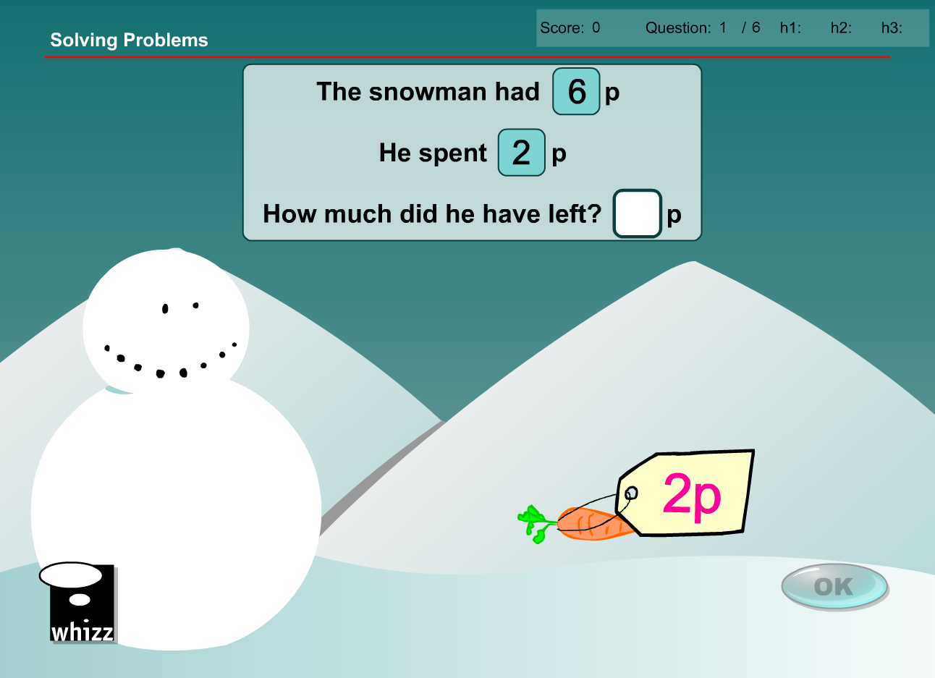

* Change 6p to 60c
* Change 2p to 20c
* Change answer to 40c

Exercise 2

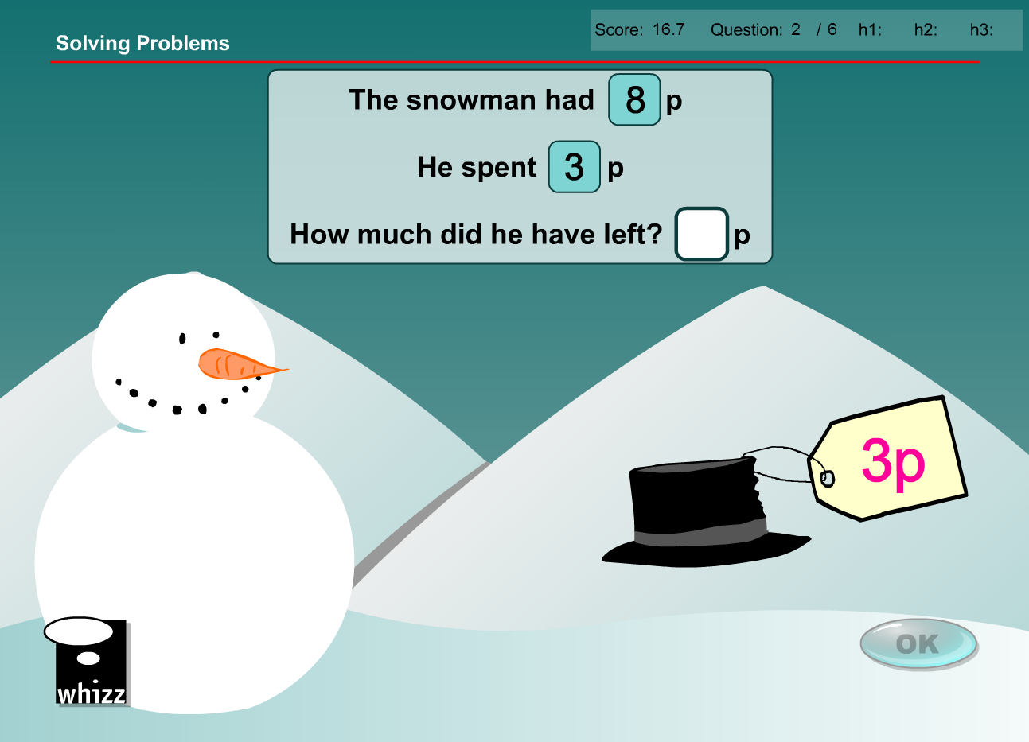

* Change 8p to 80c
* Change 3p to 30c
* Change answer to 50c

Exercise 3

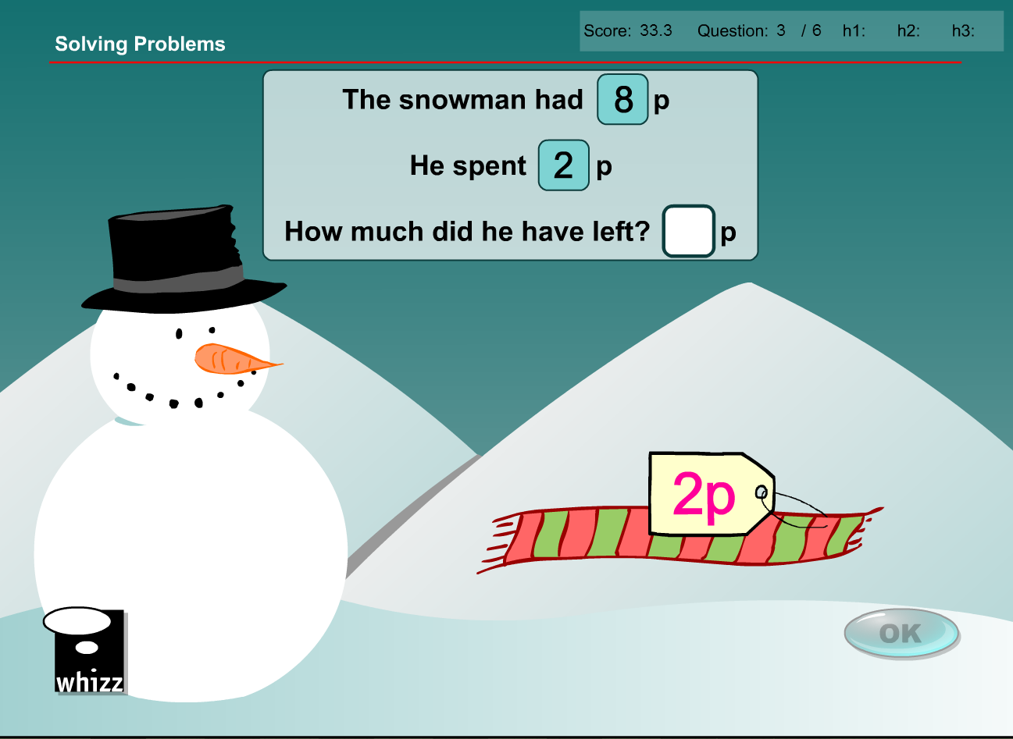

* Change 8p to 80c
* Change 2p to 20c
* Change answer to 60c

Exercise 4

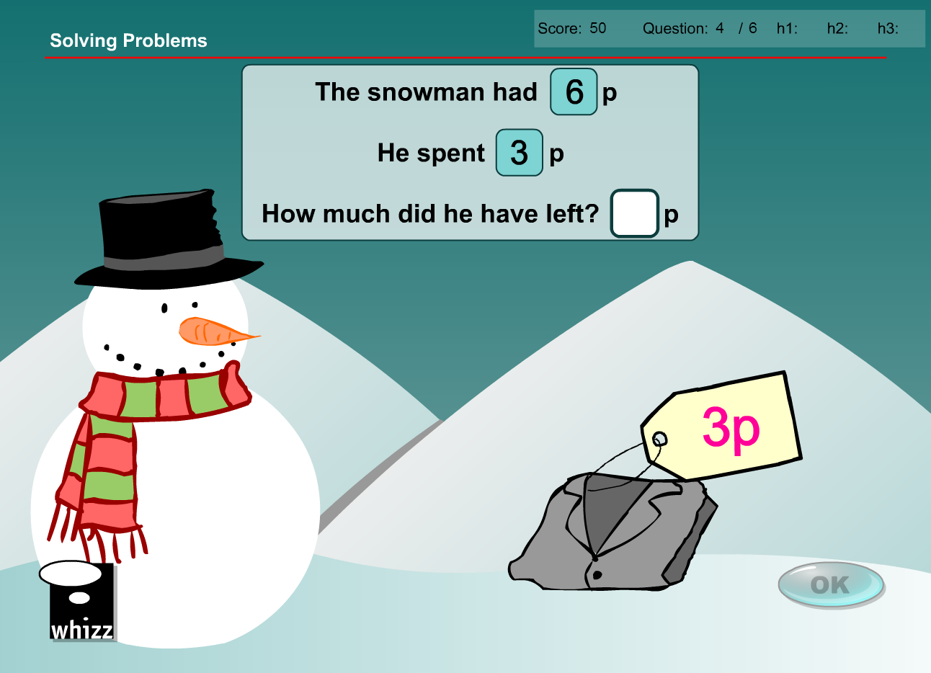

* Change 6p to 60c
* Change 3p to 30c
* Change answer to 30c

Exercise 5

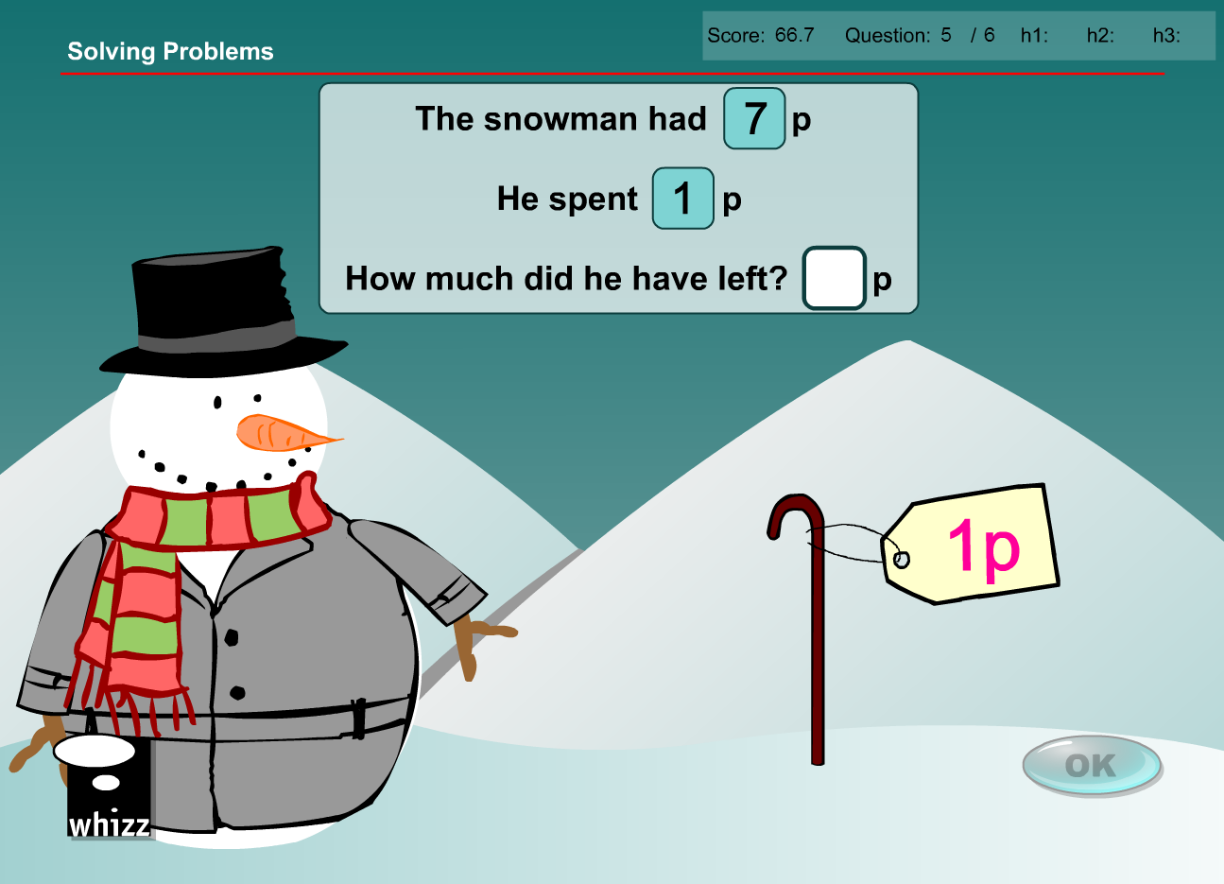

* Change 7p to 70c
* Change 1p to 10c
* Change answer to 60c

Exercise 6

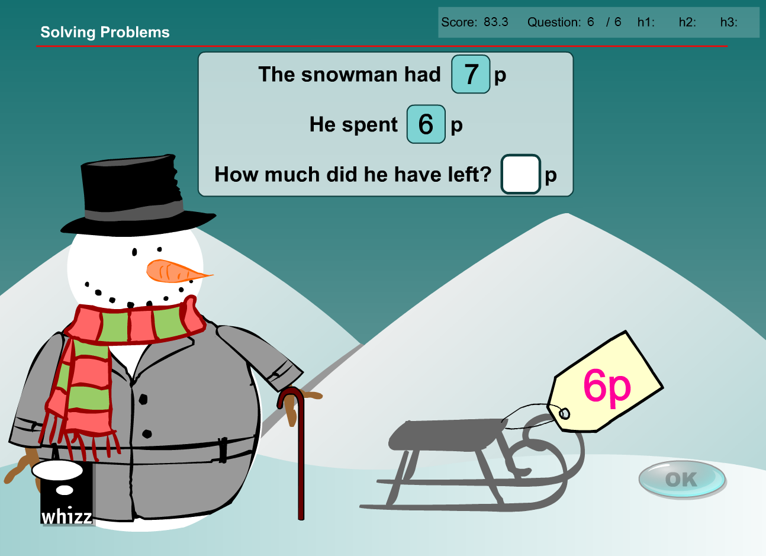

* Change 7p to 70c
* Change 6p to 60c
* Change answer to 10c

**Test content has the same issues/solution**

Increase all denominations in questions and answer by a factor of 10. Replace ‘p’ with ‘c’. Voiceover is fine and can remain.

Question 1

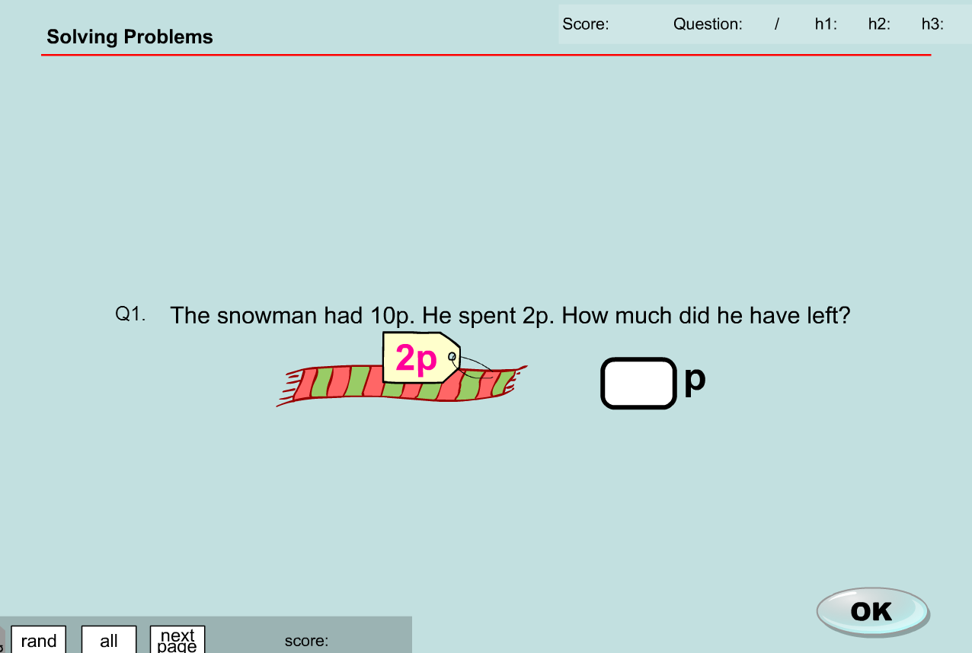

* Change 10p to 100c (or $1?)
* Change 2p to 20c
* Change answer to 80c

Question 2

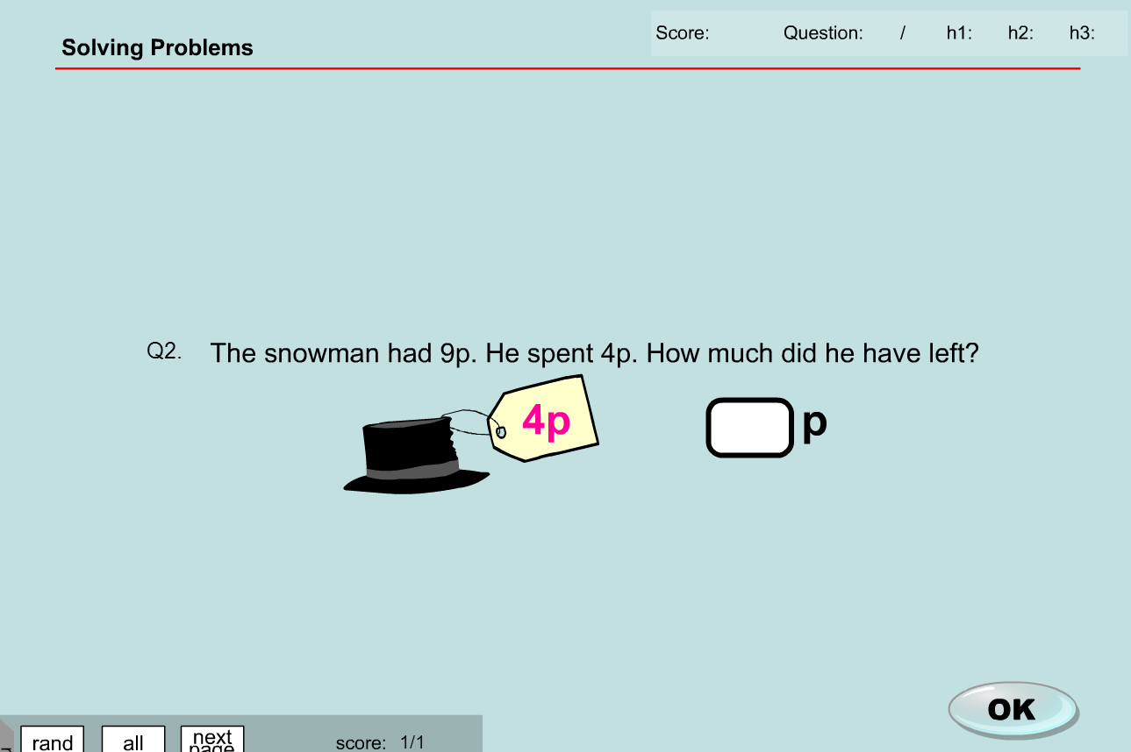

* Change 9p to 90c
* Change 4p to 40c
* Change answer to 50c

Question 3

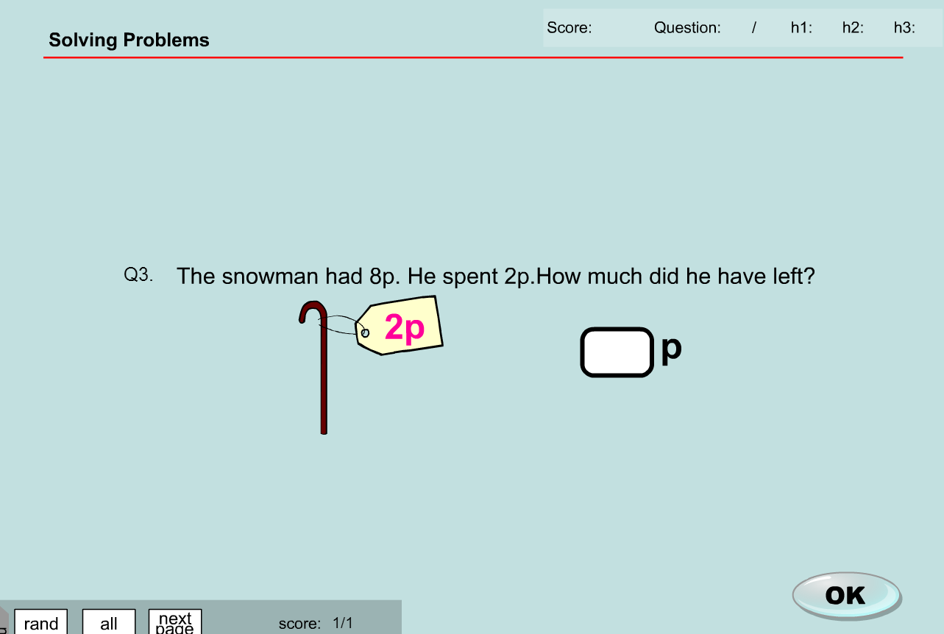

* Change 8p to 80c
* Change 2p to 20c
* Change answer to 60c

Question 4

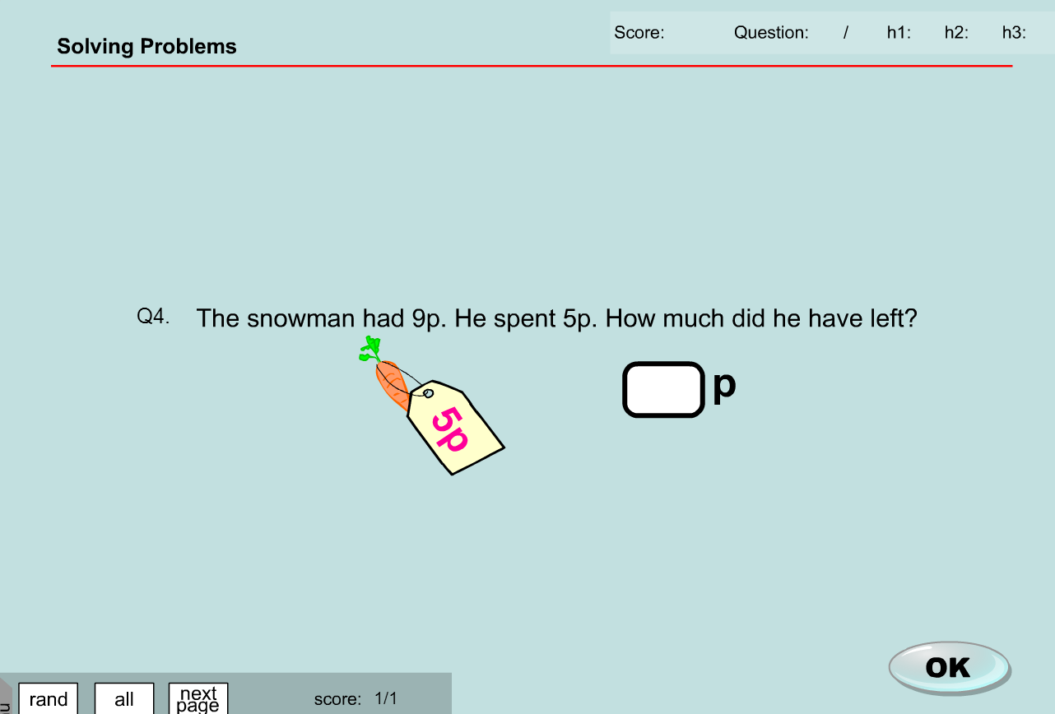

* Change 9p to 90c
* Change 5p to 50c
* Change answer to 40c

Question 5

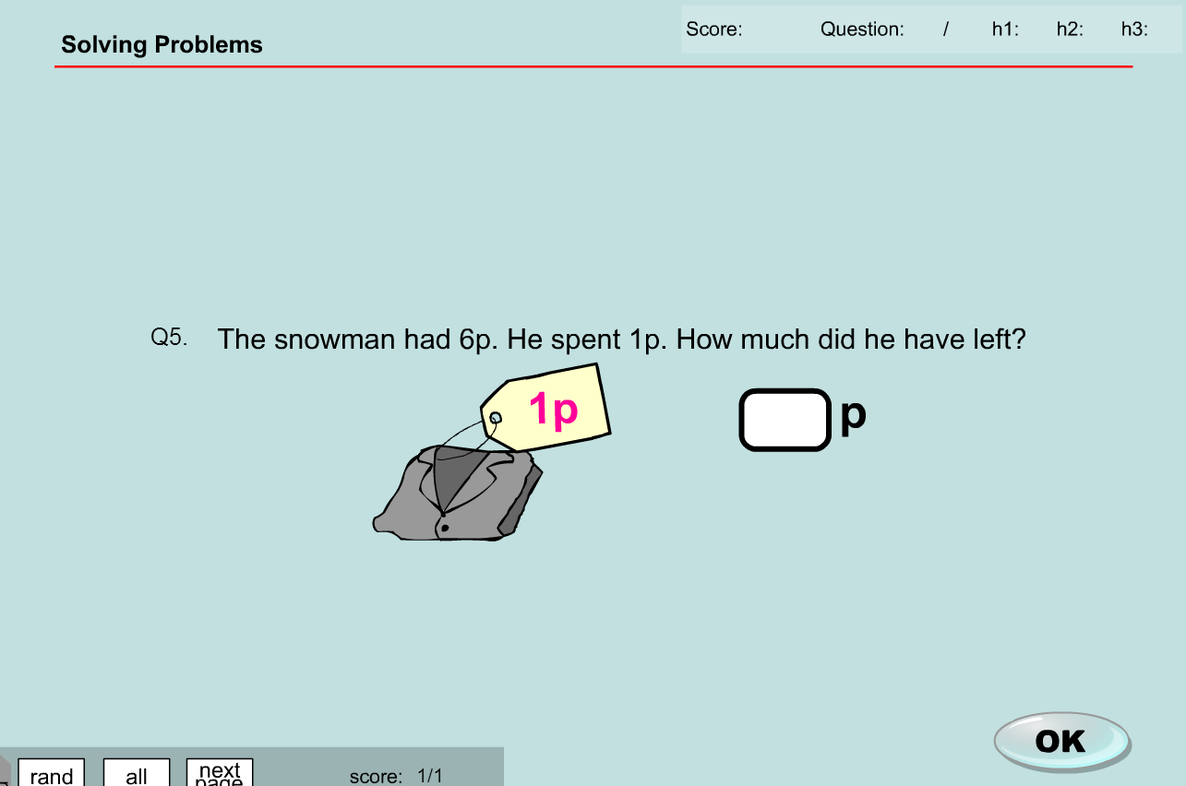

* Change 6p to 60c
* Change 1p to 10c
* Change answer to 50c

**MA_GBR_0650NAx0100**

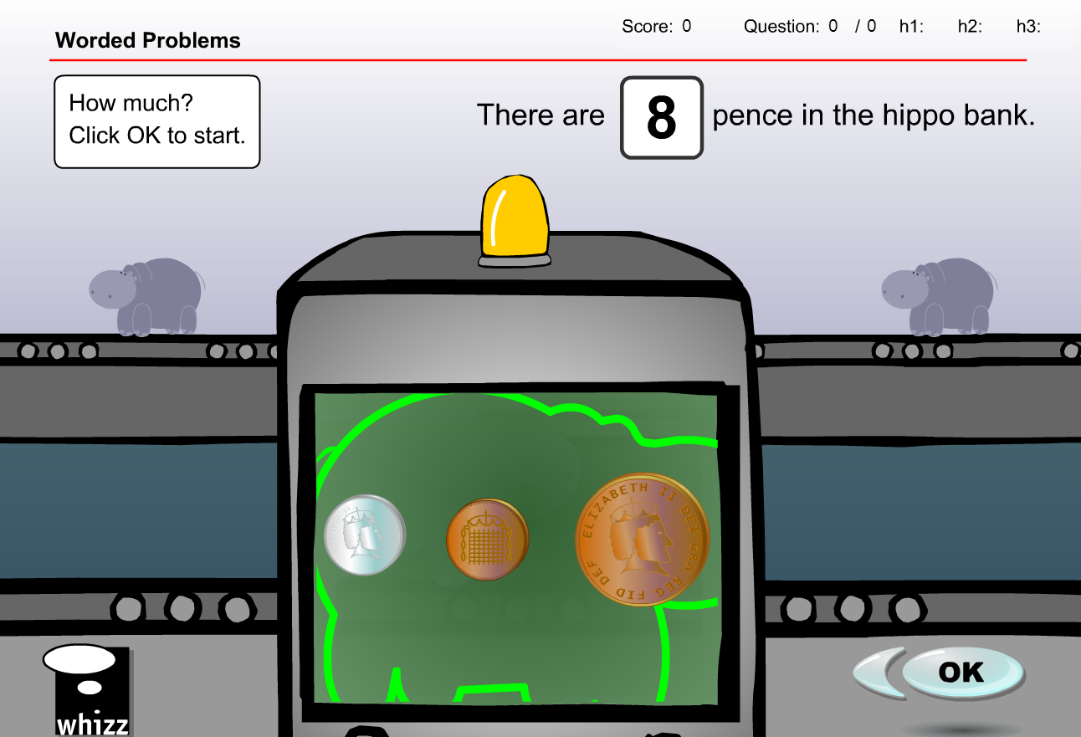

No NZ 1c coin so complete content change required as substituting with coins of different denominations would produce different answers

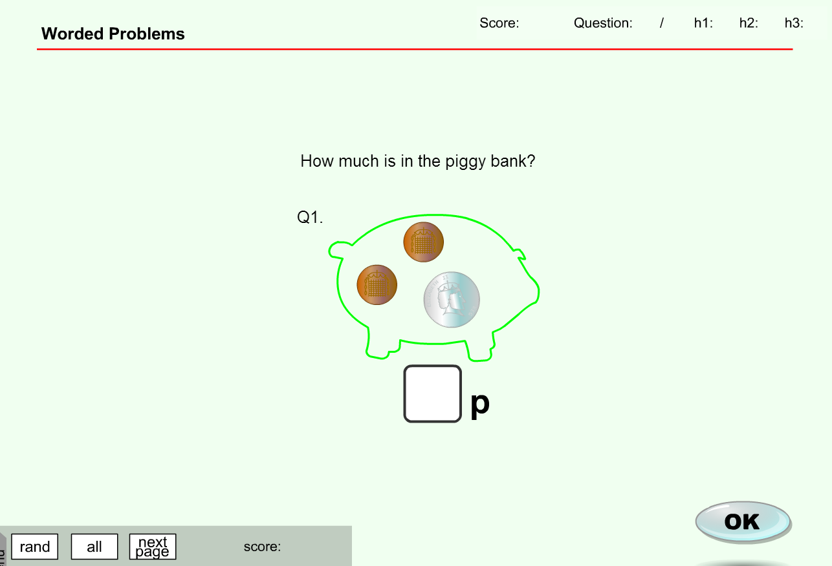

**MA_GBR_0650NAx0100 – fixes**

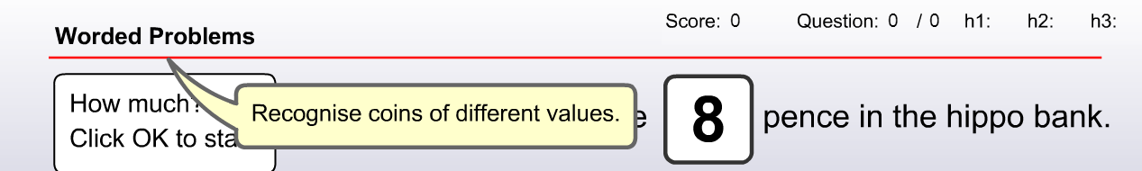

Will need to change the 6 coins (UK currency) to the 5 coins (NZ currency) 10c, 20c, 50c, $1 and $2

Change pence to cents, change ‘p’ to ‘c’

Voiceover needs removal

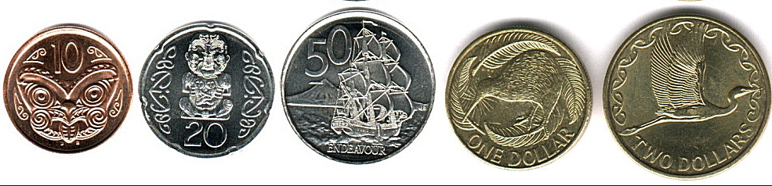

Voiceover needs removal.

Not sure how many questions in the database but it looks like more than 10 so I have given suggestions for 15 questions. Can provide more if required.

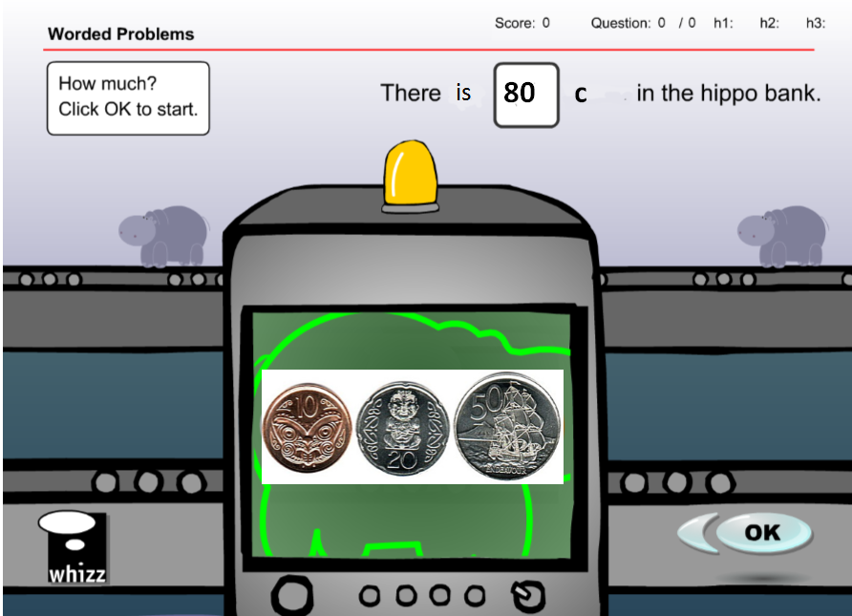

Exercise 1

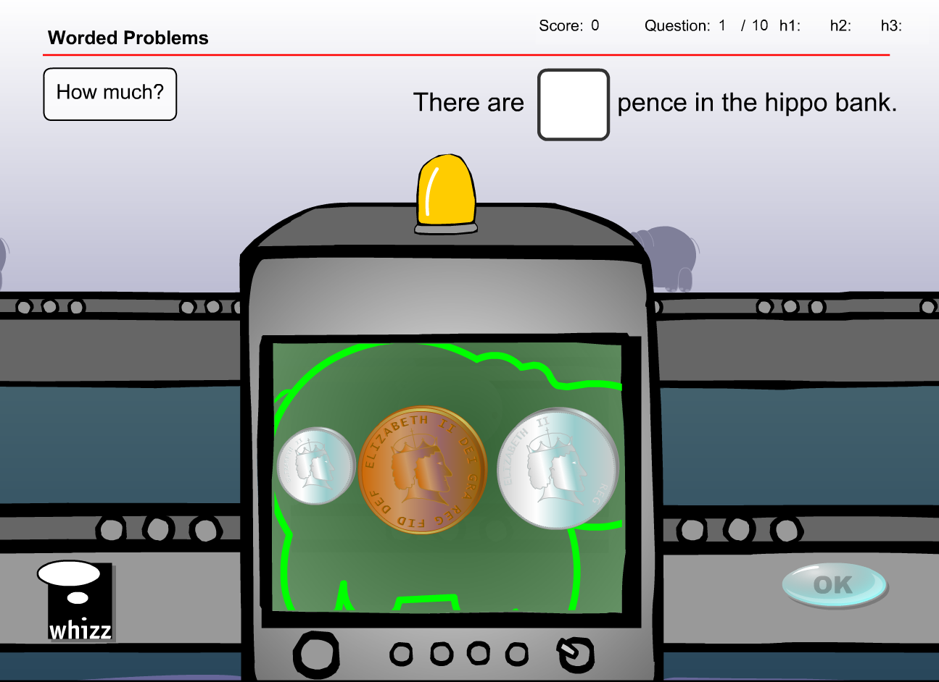

* Change ‘pence’ into ‘cents’
* Change coins to 1 x 10c and 2 x 20c
* Change answer to 50c

Exercise 2



* Change ‘pence’ into ‘cents’
* Change coins to 2 x 10c and 1 x 50c
* Change answer to 70c

Exercise 3



* Change ‘pence’ into ‘cents’
* Change coins to 1 x 20c and 1 x 50c
* Change answer to 50c

Exercise 4



* Change ‘pence’ into ‘cents’
* Change coins to 2 x 20c and 1 x 50c
* Change answer to 90c

Exercise 5



* Change ‘pence’ into ‘cents’
* Change coins to 1 x 10c, 1 x 20c and 1 x $1
* Change answer to 130c

Exercise 6



* Change ‘pence’ into ‘cents’
* Change coins to 2 x 20c and 1 x $1
* Change answer to 140c

Exercise 7



* Change ‘pence’ into ‘cents’
* Change coins to 1 x $2 and 1 x 20c
* Change answer to 220c

Exercise 8



* Change ‘pence’ into ‘cents’
* Change coins to 2 x $1 and 1 x 10c
* Change answer to 210c

Exercise 9



* Change ‘pence’ into ‘cents’
* Change coins to 1 x 20c and 2 x 50c
* Change answer to 120c

Exercise 10



* Change ‘pence’ into ‘cents’
* Change coins to 1 x 20c, 1 x 50c and 1 x $2
* Change answer to 270c

Exercise 11



* Change ‘pence’ into ‘cents’
* Change coins to 1 x 10c and 2 x $2
* Change answer to 210c

Exercise 12



* Change ‘pence’ into ‘cents’
* Change coins to 1 x 10c and 2 x 50c
* Change answer to 110c

Exercise 13



* Change ‘pence’ into ‘cents’
* Change coins to 2 x 10c and 1 x $1
* Change answer to 120c

Exercise 14



* Change ‘pence’ into ‘cents’
* Change coins to 2 x 50c and 1 x $1
* Change answer to 200c

Exercise 15



* Change ‘pence’ into ‘cents’
* Change coins to 1 x 10c, 1 x 50c and 1 x $1
* Change answer to 160c

**Test content has the same issues/solution**

Change available coins from the 6 x UK ones to the 5 x NZ ones.

It appears as though there are more than 5 questions in the database. I have included 8 possible test questions.

Question 1

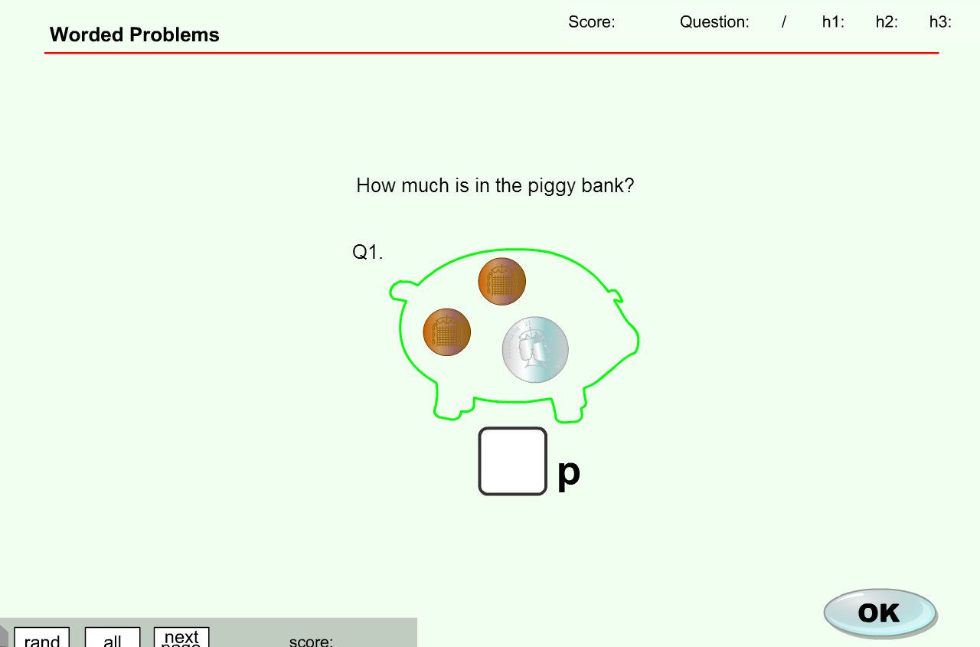

* Replace ‘p’ with ‘c’
* Change coins to 2 x 10c and 1 x 50c
* Change answer to 70c

Question 2



* Replace ‘p’ with ‘c’
* Change coins to 1 x 10c, 1 x 20c and 2 x 50c
* Change answer to 130c

Question 3



* Replace ‘p’ with ‘c’
* Change coins to 1 x 50c and 1 x $1
* Change answer to 150c

Question 4



* Replace ‘p’ with ‘c’
* Change coins to 3 x 10c and 1 x 20c
* Change answer to 50c

Question 5



* Replace ‘p’ with ‘c’
* Change coins to 1 x 10c and 2 x 20c
* Change answer to 50c

Question 6



* Replace ‘p’ with ‘c’
* Change coins to 2 x 20c and 1 x 50c
* Change answer to 90c

Question 7



* Replace ‘p’ with ‘c’
* Change coins to 1 x 10c and 3 x 20c
* Change answer to 70c

Question 8



* Replace ‘p’ with ‘c’
* Change coins to 2 x 10c, 1 x 20c and 1 x 50c
* Change answer to 90c